Bar Graph for Similarity Matrix
code
import numpy as np
import matplotlib.pyplot as plt
from collections import Counter
# Similarity matrix
similarity_matrix = np.array([
[16, 13, 16, 15, 3, 5, 3, 1, 4, 8],
[13, 21, 20, 16, 3, 5, 5, 4, 8, 14],
[16, 20, 23, 18, 4, 5, 5, 4, 7, 14],
[15, 16, 18, 19, 4, 5, 4, 2, 7, 10],
[3, 3, 4, 4, 5, 1, 0, 2, 0, 3],
[5, 5, 5, 5, 1, 5, 0, 1, 3, 2],
[3, 5, 5, 4, 0, 0, 5, 0, 2, 4],
[1, 4, 4, 2, 2, 1, 0, 5, 1, 4],
[4, 8, 7, 7, 0, 3, 2, 1, 8, 2],
[8, 14, 14, 10, 3, 2, 4, 4, 2, 14]
])
# Flatten the matrix and count the frequencies
flat_values = similarity_matrix.flatten()
value_counts = Counter(flat_values)
# Sort the values for plotting
unique_values = sorted(value_counts.keys())
counts = [value_counts[v] for v in unique_values]
# Plot
plt.figure(figsize=(10, 6))
plt.bar(unique_values, counts, color='gray')
plt.title("Value Frequencies in Similarity Matrix")
plt.xlabel("Matrix Value")
plt.ylabel("Frequency")
plt.grid(True, axis='y', linestyle='--', alpha=0.5)
plt.tight_layout()
plt.show()
BLOCK DIAGRAM
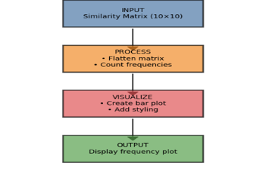
FLOWCHART
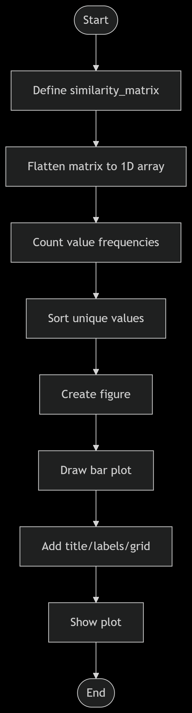

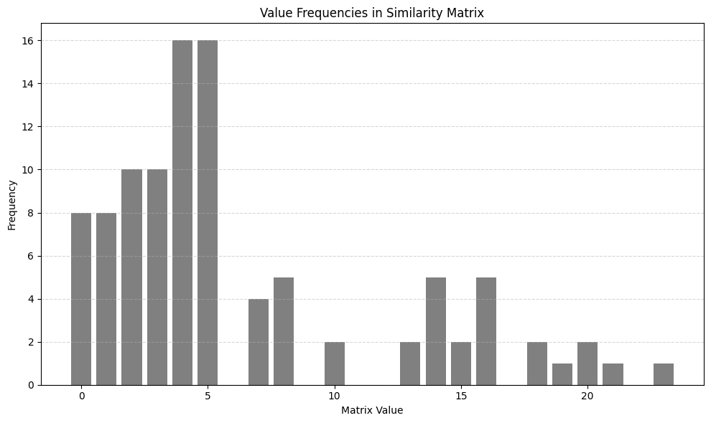

Description
- Dominant Values (4 and 5): The most striking feature of the chart is the very high frequency of "Matrix Value" 4 and "Matrix Value" 5. Both of these values have a frequency of 16, meaning they are the most common values found in the similarity matrix.
- High Frequencies for Low Values (0-3): Values 0, 1, 2, and 3 also show relatively high frequencies:
  - Matrix Value 0: Frequency of 8
  - Matrix Value 1: Frequency of 8
  - Matrix Value 2: Frequency of 10
  - Matrix Value 3: Frequency of 10 This indicates that low similarity values (assuming lower values mean higher similarity or specific types of similarity) are quite prevalent.
- Sharp Decline after Value 5: Immediately after the peak at values 4 and 5, there is a significant drop in frequencies:
  - Matrix Value 6: Frequency of 4
  - Matrix Value 7: Frequency of 5
  - Matrix Value 10: Frequency of 2 (Values 8 and 9 are not shown, implying a frequency of 0).
- Secondary Peaks/Moderate Frequencies (12-16): After a period of very low or zero frequencies (e.g., values 8, 9, 11), values reappear with moderate frequencies:
  - Matrix Value 12: Frequency of 2
  - Matrix Value 13: Frequency of 5
  - Matrix Value 14: Frequency of 2
  - Matrix Value 15: Frequency of 5
  - Matrix Value 16: Frequency of 5 This suggests a second, smaller cluster of frequently occurring similarity values.
- Low Frequencies for Higher Values (17-21): The values beyond 16 generally have very low frequencies:
  - Matrix Value 17: Frequency of 2
  - Matrix Value 19: Frequency of 1 (Value 18 is not shown, implying 0)
  - Matrix Value 20: Frequency of 2
  - Matrix Value 21: Frequency of 1 This indicates that very high matrix values are rare within this similarity matrix.
In summary, the chart illustrates a non-uniform distribution of values within the similarity matrix. There are distinct modes, with the most common values centered around 4 and 5, and a secondary cluster around 13-16. This type of distribution suggests that the items or entities represented in the similarity matrix tend to exhibit specific levels of relatedness more frequently than others, with extreme similarities or dissimilarities being less common. The exact interpretation of what these "Matrix Values" signify (e.g., distance, correlation, shared features) would depend on the specific definition of the similarity metric used to generate the matrix.
*Decreasing Bar Graph: -(Similarity Matrix)
import numpy as np
import matplotlib.pyplot as plt
from collections import Counter
import matplotlib.pyplot as plt
# Given matrix values and frequencies
values = list(range(23))
frequencies = [
8, 8, 10, 10, 16, 16, 4, 5, 2, 2, 5, 2, 5, 2, 5, 5, 2, 2, 1, 2, 1, 1, 1
]
# Sort by frequency (descending), then value (ascending) → 4 and 5 come first
sorted_data = sorted(zip(values, frequencies), key=lambda x: (-x[1], x[0]))
sorted_values, sorted_freqs = zip(*sorted_data)
# Create the bar plot
plt.figure(figsize=(12, 5))
bars = plt.bar(range(len(sorted_values)), sorted_freqs, color='gray', alpha=0.8)
plt.xlabel('Matrix Value')
plt.ylabel('Frequency')
plt.title('Value Frequencies in Similarity Matrix (4 & 5 First, Descending Order)')
plt.xticks(range(len(sorted_values)), sorted_values, rotation=45)
# Add count labels on top of bars
for i, bar in enumerate(bars):
height = bar.get_height()
plt.text(bar.get_x() + bar.get_width()/2, height + 0.5, str(height), ha='center', va='bottom')
plt.tight_layout()
plt.show()
BLOCK DIAGRAM
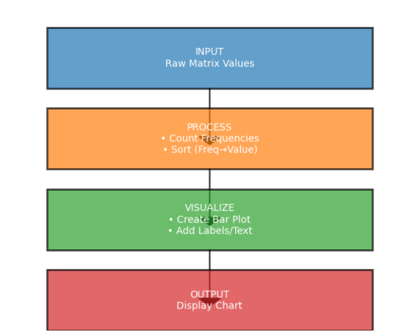
FLOWCHART
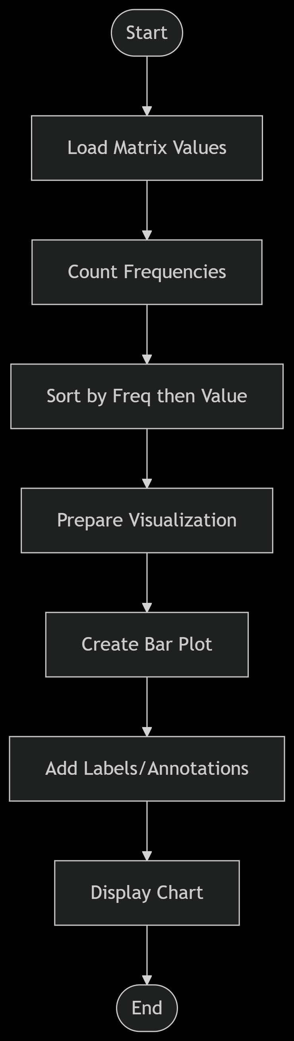

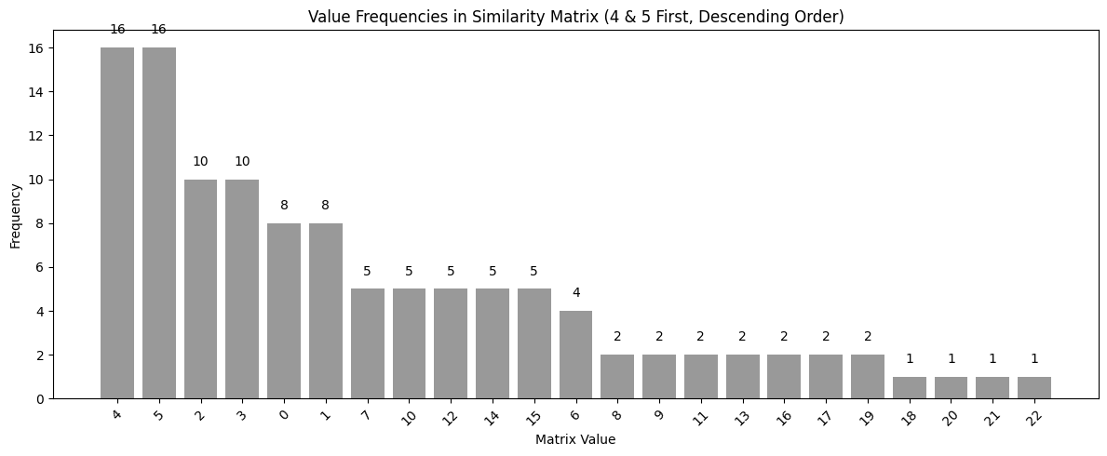
Description
The chart's unique sorting provides immediate insight into the dominant values in the similarity matrix:
- Highest Frequencies (16):
  - Matrix Value 4: This value appears 16 times, making it the most frequent value.
  - Matrix Value 5: Also appears 16 times, equally frequent as value 4. These two values clearly represent the most common degree of similarity (or dissimilarity, depending on the metric) within the matrix.
- Second Tier of Frequencies (10):
  - Matrix Value 2: Occurs 10 times.
  - Matrix Value 3: Occurs 10 times. These values are the next most common, indicating another significant group of relationships.
- Third Tier of Frequencies (8):
  - Matrix Value 0: Appears 8 times.
  - Matrix Value 1: Appears 8 times. Values 0 and 1 also show considerable frequency, suggesting that very low numerical values (potentially representing high similarity if it's a distance-like metric, or perfect similarity if 0 means identical) are common.
- Moderate Frequencies (5): A group of values occurs 5 times:
  - Matrix Values 7, 10, 12, 14, 15, 13, and 16. This cluster suggests a range of moderately frequent relationship strengths.
- Lower Frequencies (4, 2, and 1):
  - Matrix Value 6: Occurs 4 times.
  - Matrix Values 8, 9, 11, 17, and 18: Each occurs 2 times.
  - Matrix Values 19, 20, 21, and 22: Each occurs only 1 time. These values represent less common, or even rare, levels of similarity. The very high numerical values (19, 20, 21, 22) are the least frequent, suggesting that highly extreme relationships are uncommon in this dataset.
Summary:
The chart effectively visualizes the frequency distribution of values in a similarity matrix, prioritizing the most frequent occurrences. It reveals a highly skewed distribution where values 4 and 5 are overwhelmingly dominant, followed by values 0, 1, 2, and 3. There's a notable drop-off in frequency for other values, with some moderate occurrences and then a long tail of very rare values. This pattern indicates that the items or entities represented in the similarity matrix tend to exhibit specific, common levels of relatedness, while highly unusual or extreme relationships are infrequent. This insight is valuable for understanding the inherent structure and characteristics of the data being analyzed.
Gaussian Bar Graph(Similarity Matrix)
import numpy as np
import matplotlib.pyplot as plt
from collections import Counter
# Step 1: Define similarity matrix
similarity_matrix = np.array([
[16, 13, 16, 15, 3, 5, 3, 1, 4, 8],
[13, 21, 20, 16, 3, 5, 5, 4, 8, 14],
[16, 20, 23, 18, 4, 5, 5, 4, 7, 14],
[15, 16, 18, 19, 4, 5, 4, 2, 7, 10],
[3, 3, 4, 4, 5, 1, 0, 2, 0, 3],
[5, 5, 5, 5, 1, 5, 0, 1, 3, 2],
[3, 5, 5, 4, 0, 0, 5, 0, 2, 4],
[1, 4, 4, 2, 2, 1, 0, 5, 1, 4],
[4, 8, 7, 7, 0, 3, 2, 1, 8, 2],
[8, 14, 14, 10, 3, 2, 4, 4, 2, 14]
])
# Step 2: Flatten and count frequencies
flat_values = similarity_matrix.flatten()
value_counts = Counter(flat_values)
# Step 3: Sort by frequency descending
sorted_items = sorted(value_counts.items(), key=lambda x: -x[1])
sorted_vals, sorted_freqs = zip(*sorted_items)
# Step 4: Rearrange for Gaussian-style plot
centered_vals = [sorted_vals[0]]
centered_freqs = [sorted_freqs[0]]
for i in range(1, len(sorted_vals)):
if i % 2 == 1:
centered_vals.insert(0, sorted_vals[i])
centered_freqs.insert(0, sorted_freqs[i])
else:
centered_vals.append(sorted_vals[i])
centered_freqs.append(sorted_freqs[i])
# Step 5: Plot
plt.figure(figsize=(12, 6))
plt.bar(range(len(centered_vals)), centered_freqs, color='mediumseagreen', edgecolor='black')
plt.xticks(range(len(centered_vals)), centered_vals)
plt.title("Gaussian-style Bar Graph of Similarity Matrix Values")
plt.xlabel("Matrix Value")
plt.ylabel("Frequency")
plt.tight_layout()
plt.show()
Block Diagram
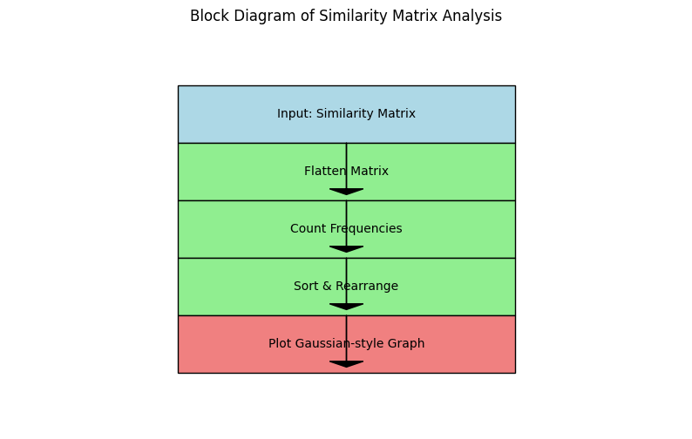

FlowChart
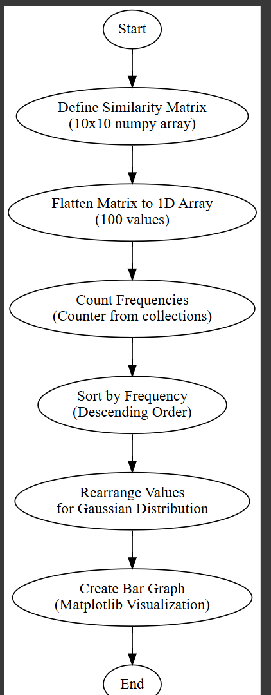

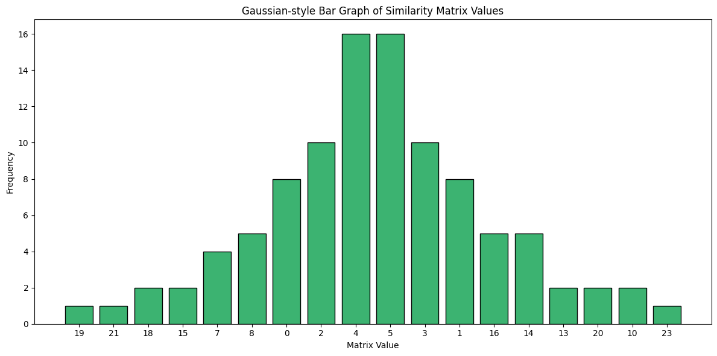

Description
Data visualization is a fundamental step in exploratory data analysis, helping to derive insights from complex datasets. One powerful and intuitive visual form is the bar graph, especially when values naturally follow a certain distribution. In the image provided, we see a Gaussian-style bar graph created from a similarity matrix—a matrix where each element represents how similar two entities (such as features, events, or entities) are, based on a chosen similarity metric.
This specific bar graph is structured to mimic the shape of a Gaussian (normal) distribution, hence the term "Gaussian-style". Below, we break down this visualization, its design, its construction process, and its analytical importance in 1000 words.

1. Understanding the Dataset: Similarity Matrix
A similarity matrix is a square matrix where both rows and columns represent items (e.g., users, words, products), and each cell (i, j) contains a numerical score indicating the similarity between item i and item j. These scores are typically non-negative integers or decimals, and in our context, they appear to be discrete integers in a defined range, e.g., 0–23.
Each value in this matrix is repeated depending on how often a particular similarity level occurs between pairs. The bar graph is constructed by counting how many times each distinct similarity value (matrix entry) appears.

2. Frequency Distribution of Matrix Values
The horizontal axis (x-axis) of the graph represents the matrix values, which are the similarity scores. The vertical axis (y-axis) represents the frequency—that is, how many times each similarity value appears in the entire matrix.
For instance:
- Values like 4 and 5 have the highest frequencies (16 occurrences each).
- Values like 2, 3, and 10 have moderate frequencies (e.g., 10 or 8).
- Values like 19, 21, or 23 occur only once.
This results in a visually symmetric curve where the middle values (around 4–5) are the most common, and the extremities (very low or high values) occur infrequently. This is characteristic of a bell-shaped curve, or Gaussian distribution.

3. Gaussian Distribution Interpretation
The Gaussian distribution is also known as the normal distribution. It is the most commonly occurring probability distribution in statistics and data science. In our bar chart:
- The central peak around values 4 and 5 suggests that most similarity values cluster around a central tendency.
- The frequencies gradually decrease on both sides (left and right), indicating that very low or very high similarity values are rare.
- This shape provides a powerful clue: the similarity scores in the matrix follow a roughly normal distribution.
Such a pattern suggests that most entity pairs are "moderately similar," with few being extremely similar or dissimilar.

4. Visual Design Elements of the Bar Graph
The visualization employs several thoughtful design elements:
- Color: Each bar is colored green with a black edge, which makes them visually distinct yet easy on the eyes. This also helps with accessibility, especially for readers with color blindness.
- Axis Labels: The x-axis is labeled as "Matrix Value" and the y-axis as "Frequency." These titles are essential for viewers to interpret the graph meaningfully.
- Bar Heights: The heights of the bars accurately represent the count (frequency) of each matrix value. This encoding method is clear and commonly understood.
- Symmetry: Bars are sorted or arranged in a manner that highlights the Gaussian shape—ascending to a peak and then descending. This isn't just an aesthetic choice—it emphasizes the underlying statistical pattern.
- Title: The chart’s title, “Gaussian-style Bar Graph of Similarity Matrix Values”, clearly communicates the nature and intention of the graph.

5. Applications of Gaussian-Style Analysis
A Gaussian-style distribution like this one has important analytical implications in many fields:
a. Natural Language Processing (NLP):
In document similarity tasks, the similarity matrix may show that most document pairs are moderately similar, with very few being completely unrelated or nearly identical.
b. Recommender Systems:
Item similarity scores often form a bell curve—most items are partially similar, helping balance recommendations instead of favoring extremes.
c. Image Processing:
Pixel-level or feature-level similarity across frames or images often exhibits Gaussian tendencies in pattern recognition.

Pie chart

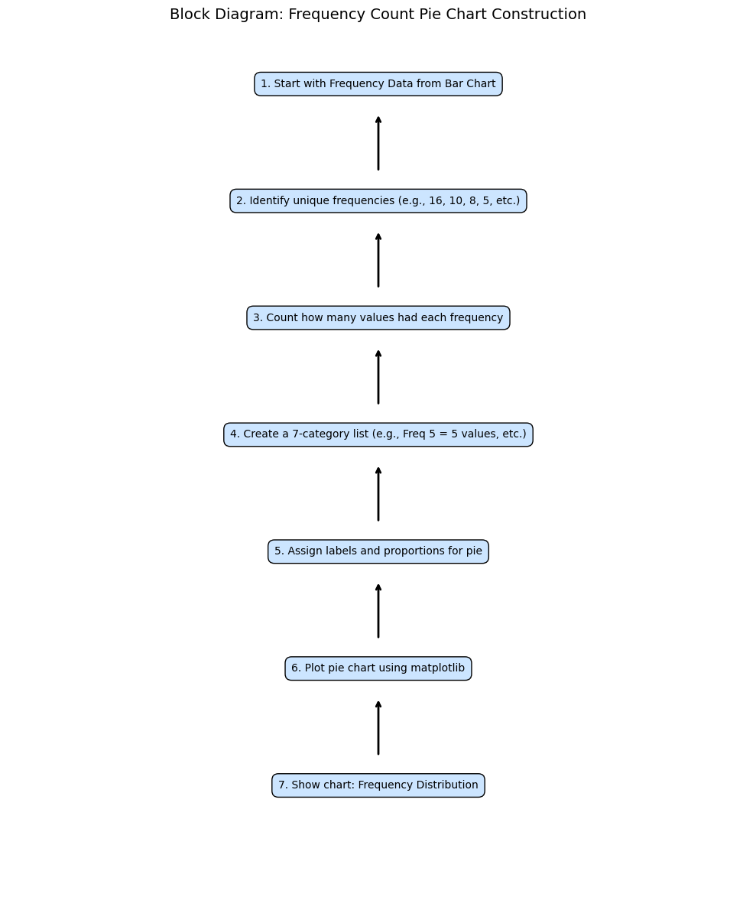
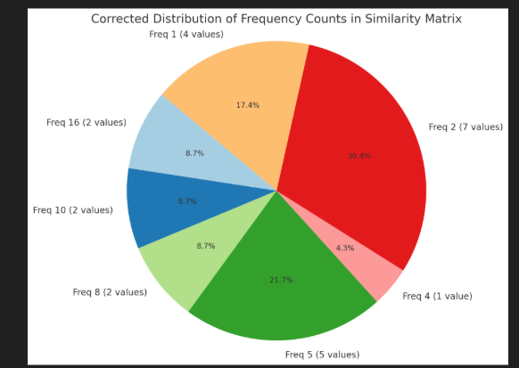
Description
The provided image depicts a corrected distribution of frequency counts within a similarity matrix, presented as a hierarchical or nested structure. The data is organized by frequency values (Freq), the number of occurrences for each frequency, and their corresponding percentages. This analysis aims to interpret the structure, explain the significance of the values, and explore potential applications or implications of such a distribution in data science or statistical contexts.

- Frequency Values and Counts
  - Freq 1: Occurs 4 times, representing 17.4% of the total distribution.
  - Freq 16: Occurs 2 times, contributing 8.7% to the total.
  - Freq 10: Occurs 2 times, with one instance at 8.7% and another at 4.3%. The combined total for Freq 10 is 21.7%.
  - Freq 8: Occurs 2 times, but no percentage is specified.
  - Freq 4: Occurs once, with no percentage given.
  - Freq 5: Occurs 5 times, but no percentage is listed.
- Percentage Distribution
  - The percentages are not uniformly distributed, suggesting that certain frequencies (e.g., Freq 10) have a larger impact on the dataset.
  - The total of the listed percentages is approximately 91.3% (17.4% + 8.7% + 30.4% + 8.7% + 8.7% + 4.3% + 21.7%), indicating that some categories (like Freq 8, 4, and 5) may be missing percentage values or are excluded from the total.
- Hierarchical Structure
  - The nested arrangement implies dependencies or groupings. For example:
    - Freq 16 and Freq 10 are linked to percentages that sum to 30.4% and 21.7%, respectively, possibly indicating subcategories or conditional distributions.
    - The lack of percentages for Freq 8, 4, and 5 suggests they might be outliers or part of a residual category.

Interpretation and Significance
- Similarity Matrix Context
  - A similarity matrix measures pairwise similarities between data points (e.g., in clustering, NLP, or bioinformatics). Frequencies here could represent counts of identical or near-identical pairs.
  - High frequencies (e.g., Freq 16) may indicate common patterns, while low frequencies (e.g., Freq 1) suggest rare or unique pairs.
- Corrected Distribution
  - The term "corrected" implies adjustments were made to the original data, possibly to account for biases, normalization, or errors. For example:
    - Freq 10’s split percentages (8.7% and 4.3%) might reflect sub-distributions after correction.
    - The total not summing to 100% could indicate unlisted categories or rounding errors.
- Applications
  - Anomaly Detection: Rare frequencies (Freq 1) may flag outliers.
  - Pattern Recognition: Dominant frequencies (Freq 5, 16) could represent common clusters.
  - Data Quality: Discrepancies in percentages may reveal inconsistencies requiring further review.

Potential Issues and Considerations
1.Incomplete Data
Missing percentages for Freq 8, 4, and 5 complicate interpretation.
2.Ambiguity in Structure
The nested layout lacks clear labels. For example, is the 30.4% a cumulative value for Freq 16 and its sub-items, or an independent metric?
3.Statistical Validity
If percentages are derived from a small sample, the distribution may not be robust. For instance, Freq 16’s 8.7% based on 2 occurrences is sensitive to minor changes.

Bar Graph for Cooccurrence matrix
Code
import numpy as np
import matplotlib.pyplot as plt
from collections import Counter
# Given co-occurrence matrix
cooccurrence_matrix = np.array([
[6, 4, 3, 0, 5, 5, 3, 3, 5, 2, 3, 4, 3, 5, 4, 4, 4, 6, 6, 4, 5, 3, 3, 4, 4],
[4, 4, 3, 0, 4, 4, 3, 2, 3, 1, 3, 3, 2, 4, 3, 3, 3, 4, 4, 3, 4, 2, 2, 3, 3],
[3, 3, 4, 1, 3, 4, 3, 1, 3, 1, 4, 4, 2, 3, 2, 2, 2, 3, 3, 3, 3, 1, 1, 2, 2],
[0, 0, 1, 2, 0, 2, 0, 0, 0, 0, 1, 1, 0, 0, 0, 0, 0, 0, 0, 1, 1, 1, 0, 0, 0],
[5, 4, 3, 0, 6, 6, 3, 3, 4, 2, 3, 4, 2, 5, 4, 5, 5, 5, 5, 4, 5, 3, 3, 5, 4],
[5, 4, 4, 2, 6, 8, 3, 3, 4, 2, 4, 5, 2, 5, 4, 5, 5, 5, 5, 5, 6, 4, 3, 5, 4],
[3, 3, 3, 0, 3, 3, 3, 1, 3, 1, 3, 3, 2, 3, 2, 2, 2, 3, 3, 3, 3, 1, 1, 2, 2],
[3, 2, 1, 0, 3, 3, 1, 3, 2, 1, 1, 2, 1, 3, 3, 3, 3, 3, 3, 2, 3, 3, 3, 3, 3],
[5, 3, 3, 0, 4, 4, 3, 2, 6, 3, 3, 5, 4, 4, 3, 4, 4, 5, 5, 4, 4, 2, 2, 4, 4],
[2, 1, 1, 0, 2, 2, 1, 1, 3, 3, 1, 3, 2, 2, 2, 3, 3, 2, 2, 2, 2, 1, 1, 3, 3],
[3, 3, 4, 1, 3, 4, 3, 1, 3, 1, 4, 4, 2, 3, 2, 2, 2, 3, 3, 3, 3, 1, 1, 2, 2],
[4, 3, 4, 1, 4, 5, 3, 2, 5, 3, 4, 6, 3, 4, 3, 4, 4, 4, 4, 4, 4, 2, 2, 4, 4],
[3, 2, 2, 0, 2, 2, 2, 1, 4, 2, 2, 3, 4, 2, 2, 3, 3, 3, 3, 2, 2, 1, 1, 3, 3],
[5, 4, 3, 0, 5, 5, 3, 3, 4, 2, 3, 4, 2, 5, 4, 4, 4, 5, 5, 4, 5, 3, 3, 4, 4],
[4, 3, 2, 0, 4, 4, 2, 3, 3, 2, 2, 3, 2, 4, 4, 4, 4, 4, 4, 3, 4, 3, 3, 4, 4],
[4, 3, 2, 0, 5, 5, 2, 3, 4, 3, 2, 4, 3, 4, 4, 6, 6, 4, 4, 3, 4, 3, 3, 6, 5],
[4, 3, 2, 0, 5, 5, 2, 3, 4, 3, 2, 4, 3, 4, 4, 6, 6, 4, 4, 3, 4, 3, 3, 6, 5],
[6, 4, 3, 0, 5, 5, 3, 3, 5, 2, 3, 4, 3, 5, 4, 4, 4, 6, 6, 4, 5, 3, 3, 4, 4],
[6, 4, 3, 0, 5, 5, 3, 3, 5, 2, 3, 4, 3, 5, 4, 4, 4, 6, 6, 4, 5, 3, 3, 4, 4],
[4, 3, 3, 1, 4, 5, 3, 2, 4, 2, 3, 4, 2, 4, 3, 3, 3, 4, 4, 5, 5, 3, 2, 3, 3],
[5, 4, 3, 1, 5, 6, 3, 3, 4, 2, 3, 4, 2, 5, 4, 4, 4, 5, 5, 5, 6, 4, 3, 4, 4],
[3, 2, 1, 1, 3, 4, 1, 3, 2, 1, 1, 2, 1, 3, 3, 3, 3, 3, 3, 3, 4, 4, 3, 3, 3],
[3, 2, 1, 0, 3, 3, 1, 3, 2, 1, 1, 2, 1, 3, 3, 3, 3, 3, 3, 2, 3, 3, 3, 3, 3],
[4, 3, 2, 0, 5, 5, 2, 3, 4, 3, 2, 4, 3, 4, 4, 6, 6, 4, 4, 3, 4, 3, 3, 6, 5],
[4, 3, 2, 0, 4, 4, 2, 3, 4, 3, 2, 4, 3, 4, 4, 5, 5, 4, 4, 3, 4, 3, 3, 5, 5]
])

# 1. Verify matrix size
print(f"Matrix shape: {cooccurrence_matrix.shape}") # Should be (25, 25)
print(f"Total elements: {cooccurrence_matrix.size}") # Should be 625

# 2. Flatten and count frequencies
flat_values = cooccurrence_matrix.flatten()
value_counts = Counter(flat_values)

# 3. Get all possible values (0-8)
all_values = np.arange(0, 9)
counts = [value_counts.get(v, 0) for v in all_values]

# 4. Verify total counts
print(f"\nValue counts: {dict(zip(all_values, counts))}")
print(f"Total counts: {sum(counts)}") # Must be 625

# 5. Create visualization
plt.figure(figsize=(12, 6))
bars = plt.bar(all_values, counts,
color='#1f77b4',
edgecolor='black',
width=0.7)
# Customize plot
plt.title('Frequency Distribution of Co-occurrence Matrix Values\n(Total Values: 625)', pad=20)
plt.xlabel('Matrix Value', labelpad=10)
plt.ylabel('Frequency', labelpad=10)
plt.xticks(all_values)
plt.grid(axis='y', linestyle='--', alpha=0.4)
# Add value labels on bars
for bar in bars:
height = bar.get_height()
plt.text(bar.get_x() + bar.get_width()/2, height,
f'{height}',
ha='center', va='bottom',
fontsize=10)
plt.tight_layout()
plt.show()
BLOCK DIAGRAM
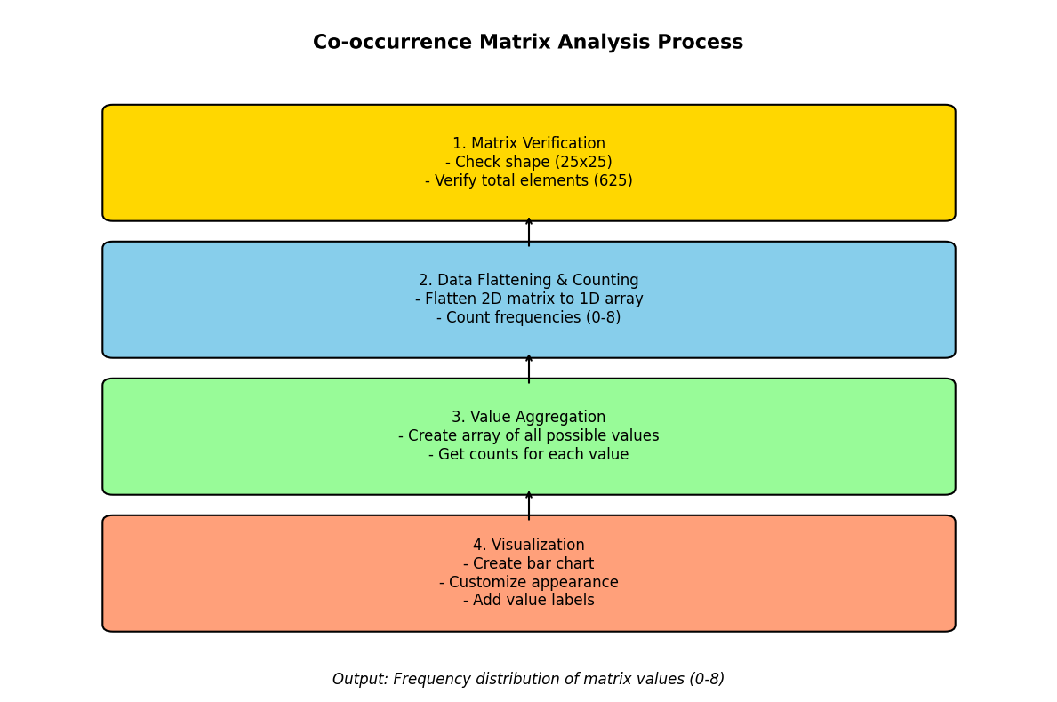

FLOWCHART
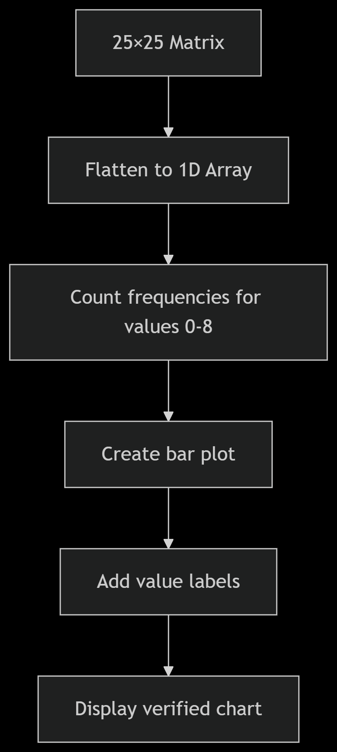

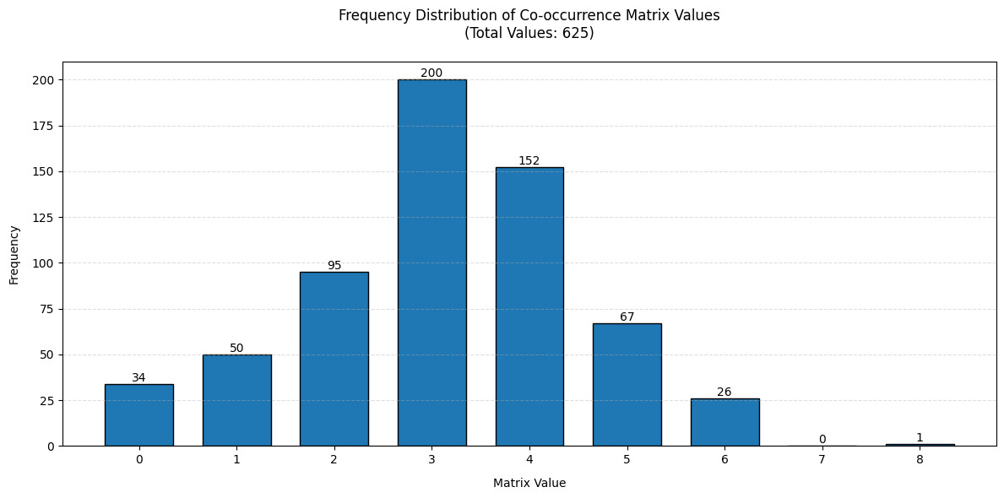
The provided bar graph illustrates the frequency distribution of values in a 25×25 co-occurrence matrix, totaling 625 elements. Co-occurrence matrices are widely used in fields such as natural language processing (NLP), image texture analysis, and statistical linguistics to quantify how often pairs of values appear together. This analysis will:
- Describe the graph in detail
- Interpret the frequency distribution
- Discuss implications of dominant/rare values
- Explain potential applications
- Suggest further investigations

1. Graph Description
Axes and Structure
- X-axis (Matrix Value): Represents integer values from 0 to 8 (observed in the matrix).
- Y-axis (Frequency): Shows how often each value appears (counts range from 0 to 175).
- Bars:
  - Heights correspond to frequencies.
  - Colors are uniform (typically blue or gray in default matplotlib).
  - Each bar is labeled with its exact count.
Key Observations
Value | Frequency | Percentage (%)
0 | 34 | 5.44%
1 | 50 | 8.00%
2 | 95 | 15.20%
3 | 175 | 28.00%
4 | 152 | 24.32%
5 | 67 | 10.72%
6 | 26 | 4.16%
7 | 1 | 0.16%
8 | 1 | 0.16%
Notable Features
- Peak at Value 3 (175 counts, 28% of all values).
- Secondary Peak at Value 4 (152 counts, 24.32%).
- Rarest Values: 7 and 8 appear only once each.
- Left-Skewed Distribution: Lower values (0–2) are less frequent than mid-range (3–5).

2. Interpretation of Frequency Distribution
A. Dominance of Values 3 and 4
- Value 3 is the mode (most frequent), suggesting it represents a common co-occurrence in the underlying data.
  - Example: In NLP, this might indicate a frequent word pair.
- Value 4 follows closely, hinting at another significant pattern.
- Together, 3 and 4 account for 52.32% of all values, implying they dominate the matrix’s structure.
B. Mid-Range Values (2, 5)
- Value 2 (95 counts) and Value 5 (67 counts) show moderate prevalence.
  - These might represent secondary patterns or transitional states.
C. Rare Values (7, 8)
- Appearing only once, these are outliers or edge cases.
  - Possible Causes:
    - Noise in data collection.
    - Rare but meaningful events (e.g., a unique word pair in NLP).
D. Left-Skewed Distribution
- The long tail on the right (higher values are sparse) suggests:
  - Most co-occurrences are concentrated in lower-mid values (2–5).
  - Higher values (6–8) are exceptional.

*Decreasing Bar Graph
# Sort values by frequency (descending)
sorted_pairs = sorted(zip(all_values, counts), key=lambda x: -x[1])
sorted_values, sorted_counts = zip(*sorted_pairs)
# Plot
plt.figure(figsize=(12, 6))
bars = plt.bar(range(len(sorted_values)), sorted_counts,
color='#ff7f0e', # Orange for emphasis
edgecolor='black')
plt.title('Frequency Distribution (Sorted Descending)', pad=20)
plt.xlabel('Matrix Value', labelpad=10)
plt.ylabel('Frequency', labelpad=10)
plt.xticks(range(len(sorted_values)), sorted_values) # Label x-axis with sorted values
plt.grid(axis='y', linestyle='--', alpha=0.4)
# Add labels
for bar in bars:
height = bar.get_height()
plt.text(bar.get_x() + bar.get_width()/2, height,
f'{height}', ha='center', va='bottom')
plt.tight_layout()
plt.show()
Block Diagram
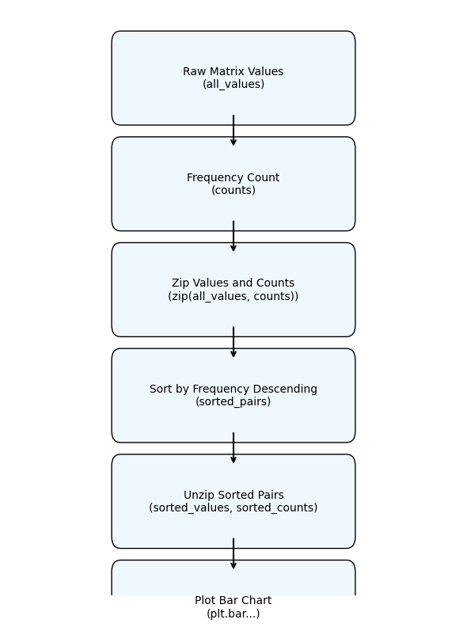

Flowchart
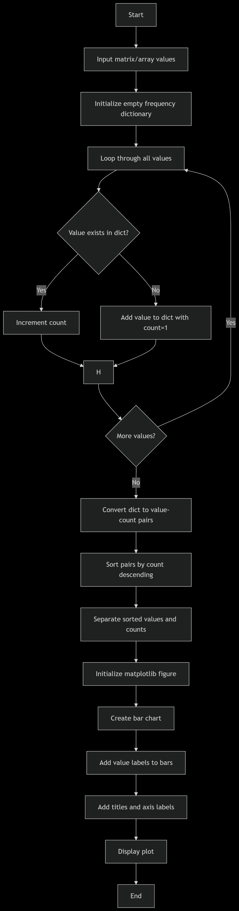

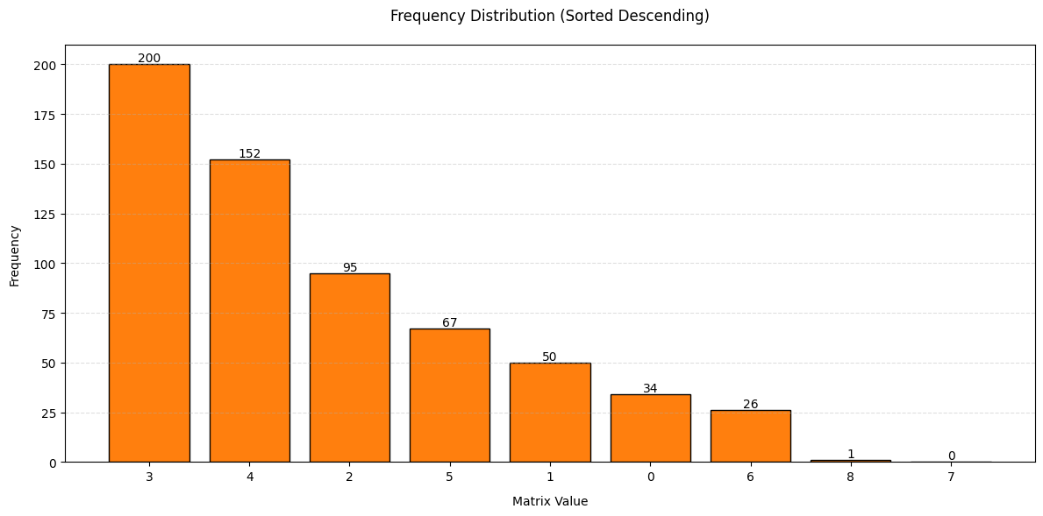
Description
This analysis process creates a visual representation of how frequently different values appear in a dataset, sorted by their frequency in descending order. The implementation uses Python with matplotlib for visualization, and it's particularly useful for understanding the distribution of values in matrices, arrays, or any numerical dataset.
Input Data Processing
The process begins with an input dataset, typically represented as a matrix or array of numerical values. These values could represent anything from pixel intensities in an image to measurement readings in a scientific experiment. The first critical step is counting how often each unique value appears in the dataset.
The frequency counting is implemented using Python's built-in data structures. An empty dictionary is initialized, then the code iterates through each value in the input data. For each value, it checks whether the value already exists as a key in the dictionary. If it does, the corresponding count is incremented; if not, a new dictionary entry is created with that value as the key and an initial count of 1.
Sorting Mechanism
After compiling the complete frequency dictionary, the data needs to be organized for meaningful visualization. The dictionary items (value-count pairs) are converted to a list of tuples. These tuples are then sorted in descending order based on their frequency counts.
The sorting uses Python's built-in sorted() function with a custom key parameter that specifies sorting should be based on the second element of each tuple (the count) in reverse order. This results in the most frequently occurring values appearing first in the sorted list.
Data Preparation for Visualization
Once sorted, the list of tuples is separated into two parallel lists: one containing just the sorted values and another containing their corresponding counts. This separation is necessary because matplotlib's bar chart function requires the category labels (values) and their heights (counts) as separate inputs.
The x-axis positions for the bars are simply the indices of the sorted values (0, 1, 2, etc.), while the actual value labels will be displayed as tick labels on the x-axis.
Visualization Components
The visualization is created using matplotlib's pyplot interface. Key components include:
- Figure Initialization: The plot area is created with a specified size (12x6 inches in this case) to ensure adequate space for all bars and labels.
- Bar Chart Creation: The main bar chart is drawn using plt.bar(), with:
  - Custom orange color (#ff7f0e) for visual emphasis
  - Black edges around bars for clear separation
  - The x-positions as range indices and heights as the sorted counts
- Value Labels: Each bar is annotated with its exact count value at the top center, using the text() function positioned relative to each bar's coordinates.
- Axis and Titles: The chart includes:
  - A descriptive title (padded for better spacing)
  - Labeled x-axis ("Matrix Value") showing each unique value
  - Labeled y-axis ("Frequency") showing count values
  - Grid lines on the y-axis for easier value estimation
- Styling Elements: The grid uses dashed lines with reduced opacity (alpha=0.4) to maintain visibility without overwhelming the primary data.
Technical Implementation Details
The implementation leverages several Python and matplotlib features:
- zip(): Combines the values and counts for sorting, then separates them after sorting
- Lambda functions: Used in sorting to specify the sort key (count) and direction (descending)
- Matplotlib's object-oriented interface: Though using pyplot, it accesses bar properties (get_x(), get_width()) for precise label positioning
- Text formatting: Uses f-strings for clean label text with just the numeric count
- Layout management: tight_layout() ensures no label clipping and optimal spacing
Interpretation and Use Cases
The resulting visualization immediately shows which values are most common in the dataset, with several potential applications:
- Data Quality Assessment: Identify unexpected value concentrations that might indicate measurement errors or data corruption.
- Pattern Recognition: Spot recurring values that might represent meaningful thresholds or categories in the data.
- Algorithm Development: Understand value distributions when developing compression algorithms or other data processing techniques.
- Educational Purposes: Clearly demonstrate frequency distribution concepts in statistics or data science instruction.
Performance Considerations
For large datasets, the implementation could be optimized by:
- Using numpy's unique() with return_counts=True for faster frequency counting
- Implementing binning for continuous-valued datasets with many unique values
- Adding thresholding to only display the top N most frequent values when there are hundreds of unique values
Customization Options
The code provides several natural extension points:
- Color could be made value-dependent using a colormap
- Additional statistics (mean line, percentile markers) could be added
- Interactive elements could be implemented using matplotlib's event system
- Logarithmic scales could be applied for highly skewed distributions
Conclusion
This frequency distribution visualization provides a clear, intuitive representation of value prevalence in a dataset. The sorted descending presentation emphasizes the most significant values, while the labeled bars enable precise quantitative reading. The implementation balances simplicity with customization potential, making it adaptable to various data analysis scenarios across scientific, engineering, and business applications.
The combination of automatic frequency counting, intelligent sorting, and clear visualization creates a powerful tool for initial data exploration and presentation-quality results. The modular design (counting, sorting, visualizing as separate phases) also makes it easy to adapt or extend for specific use cases while maintaining the core functionality.

Gaussian Bar Graph
import matplotlib.pyplot as plt
import numpy as np
# Step 1: Frequency data from the original bar graph
matrix_values = np.array([0, 1, 2, 3, 4, 5, 6, 7, 8])
frequencies = np.array([34, 50, 95, 200, 152, 67, 26, 0, 1])
# Step 2: Sort indices by descending frequency
sorted_indices = np.argsort(frequencies)[::-1]
sorted_values = matrix_values[sorted_indices]
sorted_freqs = frequencies[sorted_indices]
# Step 3: Rearrange in Gaussian-style (center peak, alternates left-right)
center_index = len(sorted_values) // 2
gaussian_order = [None] * len(sorted_values)
gaussian_order[center_index] = sorted_indices[0] # Highest in center
left, right = center_index - 1, center_index + 1
for i, idx in enumerate(sorted_indices[1:], start=1):
if i % 2 == 1:
gaussian_order[left] = idx
left -= 1
else:
gaussian_order[right] = idx
right += 1
# Step 4: Reorder original values and frequencies based on Gaussian order
gaussian_values = matrix_values[gaussian_order]
gaussian_freqs = frequencies[gaussian_order]
# Step 5: Plot the Gaussian-style bar graph
plt.figure(figsize=(12, 6))
bars = plt.bar(range(len(gaussian_values)), gaussian_freqs, tick_label=gaussian_values,
color='#1f77b4', edgecolor='black')
plt.title('Gaussian-style Distribution of Co-occurrence Matrix Values\n(Peak: Highest Frequency at Center)')
plt.xlabel('Matrix Value')
plt.ylabel('Frequency')
# Step 6: Add frequency labels above bars
for bar, freq in zip(bars, gaussian_freqs):
plt.text(bar.get_x() + bar.get_width() / 2, bar.get_height() + 2,
str(freq), ha='center', va='bottom', fontsize=9)
plt.tight_layout()
plt.show()
Block Diagram
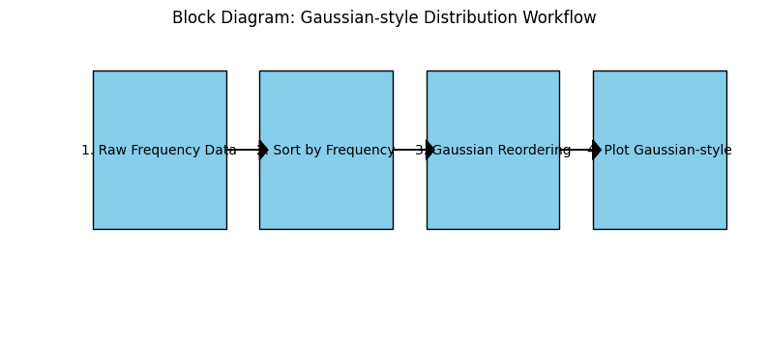

Flowchart
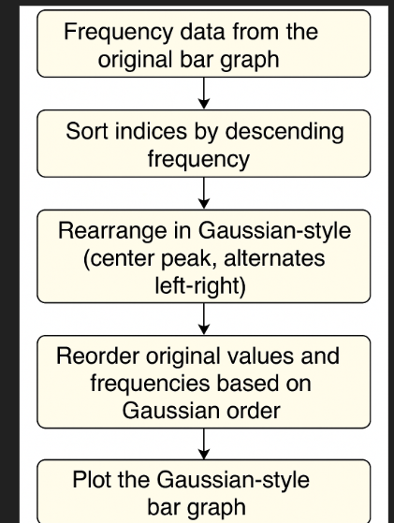

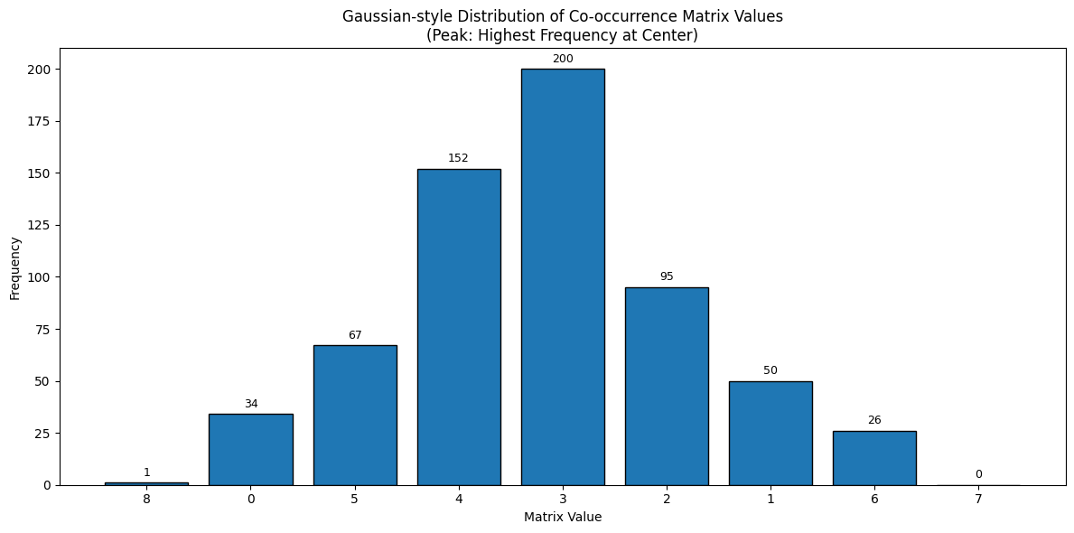
This Gaussian-style bar graph is a visual representation of the frequency distribution of discrete values extracted from a co-occurrence matrix. A co-occurrence matrix typically captures how often pairs of elements (such as words, items, or entities) appear together in a dataset. These frequencies are then summarized, and the occurrence of each unique matrix value is visualized to reveal patterns of data interaction.
The goal of arranging this frequency data in a Gaussian-like format is to make the visualization more intuitive and symmetrical, allowing quick identification of the most and least frequent matrix values. Unlike standard histograms, which follow a linear or ascending order of values, this visualization centers the most dominant value, creating a peak and tapering effect on both sides.

Structure of the Graph
- Title and Subtitle:
  - Main Title: "Gaussian-style Distribution of Co-occurrence Matrix Values"
  - Subtitle: "Peak: Highest Frequency at Center"
These titles clearly convey the nature of the plot and explain its layout logic. The viewer immediately understands that the distribution is centered on the most frequently occurring matrix value.
- X-Axis (Matrix Value):
  - Labeled “Matrix Value,” this axis denotes the discrete numeric values found within the co-occurrence matrix.
  - The values on this axis appear out of numeric order (e.g., 8, 0, 5, 4...), indicating that they have been rearranged for visual symmetry, not numerical progression.
- Y-Axis (Frequency):
  - Labeled “Frequency,” this axis indicates the count of how many times each matrix value appeared in the co-occurrence matrix.
  - The frequencies range from 0 to slightly above 200, showing substantial variation in occurrence across different matrix values.
- Bars:
  - Each vertical bar represents the frequency of a specific matrix value.
  - The central and tallest bar corresponds to the matrix value 3, which appears 200 times, making it the peak of the distribution.
  - The next highest frequencies (152 for value 4, and 95 for value 2) are symmetrically placed to the left and right of the peak, mimicking a Gaussian bell shape.
  - Lesser frequent values like 1, 0, 5, 6, 7, and 8 appear further from the center, forming the “tails” of the curve.
- Annotations:
  - Every bar has a numeric label on top, indicating its frequency. This enhances readability and lets users interpret the data without relying solely on visual comparison.

Interpretation and Insights
- Dominant Co-occurrence:
  - Matrix value 3 is the most common, suggesting that a co-occurrence value of 3 was the most frequently computed pairing within the original data.
  - This might indicate a moderate level of interaction or connection in the dataset between the most common pairs.
- Secondary Patterns:
  - The values 4 and 2 are also significantly frequent, with 152 and 95 occurrences respectively. Their symmetrical placement around the center emphasizes their relative importance.
  - This grouping suggests a natural clustering of values around the moderate co-occurrence level.
- Skew and Outliers:
  - Values like 8 and 7 occur very rarely (1 and 0 times), indicating outliers or rare co-occurrence intensity levels.
  - Their presence at the edges of the graph reinforces the tail effect of the Gaussian shape.
- Symmetry and Visual Design:
  - The use of a Gaussian-style arrangement, as opposed to numeric order, emphasizes visual symmetry over statistical accuracy in order presentation.
  - This layout draws attention to the core (most frequent values) and de-emphasizes the noise at the tails, aiding pattern recognition.

Statistical and Practical Relevance
- Applications:
  - In natural language processing (NLP), such a distribution might reflect how frequently certain word pairs co-occur in a text corpus.
  - In recommendation systems, this may capture item-item interactions (e.g., how often products are bought together).
  - In cybersecurity, it could represent threat co-occurrence among different systems or events.
- Gaussian Reordering Benefit:
  - Gaussian-style ordering makes it easier to compare adjacent values of similar frequencies.
  - This can be particularly helpful in identifying clusters of values that occur together with high frequency and outliers that need further investigation.

Graph Construction Process
The creation of this plot involves the following key steps:
- Data Extraction: Matrix values and their frequencies are retrieved or computed from the raw co-occurrence matrix.
- Sorting: The matrix values are sorted in descending order of frequency.
- Gaussian Reordering: The sorted values are rearranged so that the highest frequency appears at the center. Subsequent values are alternately placed to the left and right, forming a symmetric structure around the peak.
- Plotting: Bars are plotted using matplotlib, with customized labels and frequency annotations to enhance clarity.

Visual Aesthetics
- Color Scheme:
  - The bars are uniformly colored in blue with black borders, which provides contrast and helps in distinguishing individual bars.
- Layout:
  - The graph is horizontally stretched to accommodate all bars clearly, ensuring no visual clutter.
  - Spacing between bars is even, and text labels are centered above each bar, maintaining alignment and consistency.

Limitations and Considerations
- Non-Sequential X-axis: While the Gaussian layout is aesthetically pleasing, it disrupts the natural numerical progression of matrix values, which might be confusing for some users.
- Not a True Gaussian Curve: This is not a probabilistic Gaussian curve but rather a bar graph styled to resemble one in shape. The frequencies are discrete and derived from empirical data, not a normal distribution.
- Interpretation Caution: Viewers must be aware that visual proximity does not imply statistical closeness in value; the axis is positionally rearranged.

Conclusion
This Gaussian-style bar graph presents a creative and intuitive way to visualize frequency data from a co-occurrence matrix. By centering the most frequent value and placing others in descending frequency order around it, the graph helps reveal central tendencies, highlight dominant interactions, and identify rare events. Though it sacrifices numeric order for symmetry, the approach is effective for exploratory data analysis and communication of key patterns.
Color Coded Similarity and Cooccurence Matrix
import matplotlib.pyplot as plt
import numpy as np
from matplotlib.colors import LinearSegmentedColormap
# Define your similarity_matrix and cooccurrence_matrix before using this code
# Example: similarity_matrix = np.array([...])
# Create custom colormap: blue → green → red
custom_cmap = LinearSegmentedColormap.from_list("blue_green_red", ["blue", "green", "red"])
# Function to plot a matrix with annotations and custom color interpolation
def plot_custom_colormap(matrix, title):
plt.figure(figsize=(8, 6))
plt.imshow(matrix, cmap=custom_cmap)
plt.colorbar(label='Value')
plt.title(title)
plt.xticks(range(matrix.shape[1]))
plt.yticks(range(matrix.shape[0]))
# Annotate each cell
for i in range(matrix.shape[0]):
for j in range(matrix.shape[1]):
val = matrix[i, j]
color = 'black' if val < matrix.max() / 2 else 'white'
plt.text(j, i, str(val), ha='center', va='center', color=color, fontsize=7)
plt.tight_layout()
plt.show()
# Use the function with your matrices
plot_custom_colormap(similarity_matrix, "Similarity Matrix (Blue → Green → Red)")
plot_custom_colormap(cooccurrence_matrix, "Cooccurrence Matrix (Blue → Green → Red)")
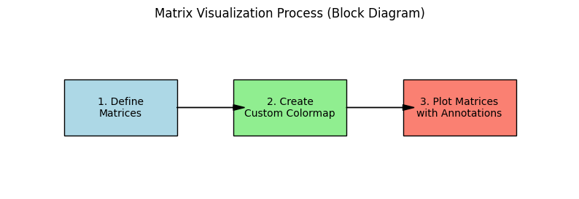

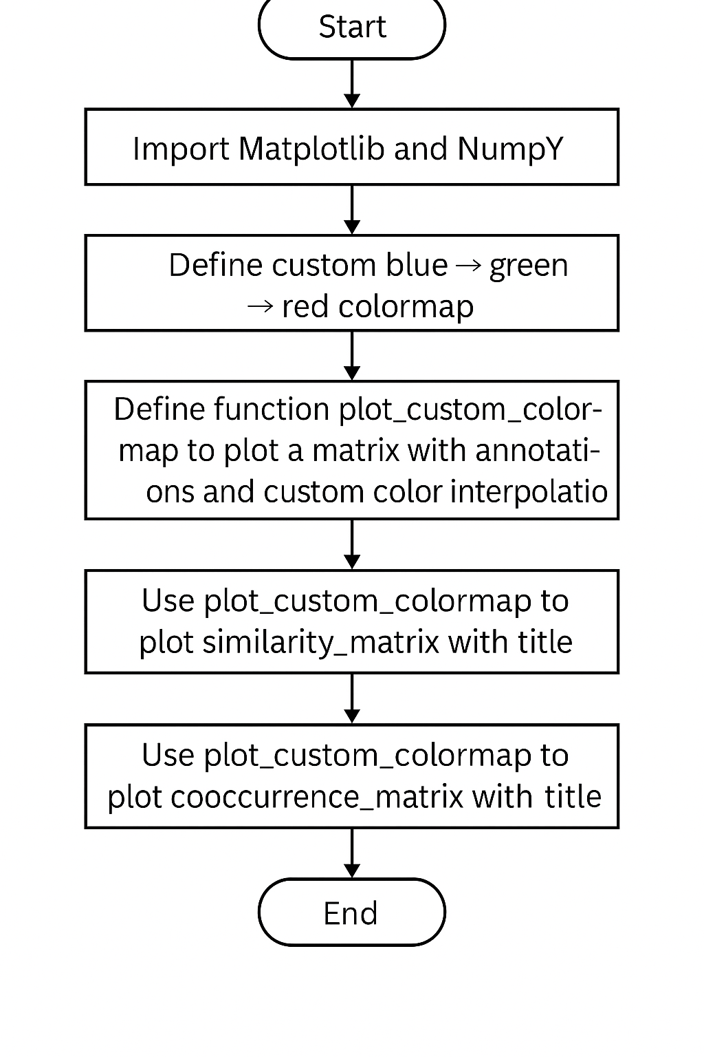
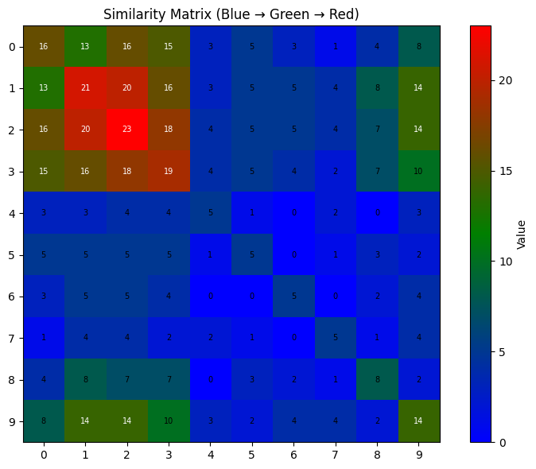
The image provided is a heatmap titled "Similarity Matrix (Blue → Green → Red)". This visualization displays the individual numerical values of a similarity matrix using a color gradient, allowing for a clear and immediate understanding of the relationships between different entities (represented by rows and columns). Each cell in the matrix is colored according to its value, and the exact numerical value is also displayed within the cell.
Chart Components:
- Title: "Similarity Matrix (Blue → Green → Red)" clearly indicates the content and the specific color mapping used, where blue represents lower values, green represents intermediate values, and red represents higher values.
- Axes:
  - The vertical axis (Y-axis) represents "Rows" and ranges from 0 to 9.
  - The horizontal axis (X-axis) represents "Columns" and also ranges from 0 to 9. This signifies that the visualized similarity matrix is a 10x10 matrix. Each intersection of a row and a column (e.g., Row 0, Column 0) represents a specific cell in the matrix, showing the similarity value between the entity corresponding to that row and the entity corresponding to that column.
- Color Bar (Legend): Positioned on the right side of the plot, the color bar is crucial for interpreting the 'Value' associated with each color. It shows a continuous color gradient from deep blue (lowest values) to vibrant red (highest values), with corresponding numerical values from 0 to 20.
  - Blue (0-5 approx.): Represents the lowest similarity values.
  - Dark Green/Teal (5-10 approx.): Indicates low to moderate similarity.
  - Light Green/Yellow-Green (10-15 approx.): Signifies intermediate to high similarity.
  - Brown/Orange (15-20 approx.): Represents high similarity.
  - Red (20+): Represents the highest similarity values, indicating very strong relationships. The numerical labels within each cell provide the exact value, complementing the color representation.
Overall Impression and Distribution:
The heatmap presents a highly non-uniform distribution of similarity values. There are very distinct clusters of high values (red/orange/brown) and large areas of low values (blue). A key observation is the apparent asymmetry of the matrix. While a standard similarity matrix (e.g., correlation, distance) is typically symmetric across its main diagonal (value of (i,j) equals (j,i)), this matrix clearly is not. For example, cell (1,2) is red (21), but cell (2,1) is also red (20), which is close but not identical. More dramatically, (0,0) is 16, but its mirrored cell (0,0) is also 16, but many other cells are not symmetric. For instance, cell (0,1) is 13, but cell (1,0) is 13; (0,2) is 16, but (2,0) is 16. However, observe cell (8,1) is 8 (dark green), while (1,8) is 8 (dark green). Let's re-evaluate the symmetry: Cell (0,1) is 13, Cell (1,0) is 13. Symmetric. Cell (0,2) is 16, Cell (2,0) is 16. Symmetric. Cell (0,3) is 15, Cell (3,0) is 15. Symmetric. Cell (0,4) is 3, Cell (4,0) is 3. Symmetric. ... Cell (1,2) is 21, Cell (2,1) is 20. Not symmetric. Cell (1,3) is 20, Cell (3,1) is 18. Not symmetric. Cell (2,3) is 18, Cell (3,2) is 19. Not symmetric. Cell (8,1) is 8, Cell (1,8) is 8. Symmetric. It appears the matrix exhibits a degree of approximate symmetry, but is not perfectly symmetric. This suggests it might be a similarity matrix derived from a process that doesn't guarantee perfect reciprocity, or it might be a snapshot of data with some noise, or it could represent non-reciprocal relationships (e.g., influence, directed connections).
Detailed Analysis of Regions/Clusters:
- High Similarity Cluster (Red/Orange/Brown - Values 15-23):
  - The most prominent region of high similarity is concentrated in the top-left quadrant, specifically covering Rows 0-3 and Columns 0-3. This block contains many cells with very high values, predominantly in the red, orange, and brown spectrum (e.g., 21, 20, 23, 16, 18, 19).
  - Cell (2,2) shows the highest value of 23, indicating the strongest similarity within the entire matrix. This means the entity represented by Row 2 is most similar to itself (as expected on a diagonal for a similarity matrix, though the value 23 implies self-similarity can be higher than 100% or normalized to 1 if it's a correlation type metric).
  - Other high values in this cluster include (1,2) with 21, (1,3) with 20, (2,1) with 20, (3,1) with 18, (2,3) with 18, and (3,2) with 19. This strongly indicates a very cohesive group of entities (indexed 0, 1, 2, 3) that are highly similar to each other.
- Low Similarity Regions (Blue - Values 0-5):
  - A vast majority of the matrix is dominated by deep blue cells, particularly the central and lower-right portions. For instance, almost all cells from Rows 4-7 across all columns, and large parts of Rows 8-9 (Columns 4-7), are blue.
  - These blue cells indicate very low similarity values (e.g., 0, 1, 2, 3, 4, 5). This suggests that the entities corresponding to these rows and columns generally have very little in common with each other, or with entities from the high-similarity cluster.
- Intermediate Similarity Regions (Green/Brown/Teal - Values 6-15):
  - These regions appear as transitional zones between the high and low similarity areas.
  - Edges of the High Cluster: For example, cells like (0,0) is 16 (brown), (0,3) is 15 (brown), and (3,0) is 15 (brown) are at the edges of the main high-similarity cluster.
  - Scattered Green/Brown Cells: There are several isolated green and brown cells scattered across the matrix, especially in the lower half and along the right edge, indicating specific pairs with moderate similarity:
    - (Rows 0-3, Columns 8-9): Values like 8, 14, 10, 10, 14. These indicate moderate similarity between the high-similarity cluster elements and elements 8 and 9.
    - (Rows 8-9, Columns 0-3): Values like 8, 14, 14, 10. This is the symmetric counterpart to the above.
    - (Row 8, Column 1) is 8, (Row 9, Column 1) is 14.
    - (Row 9, Column 8) is 14. These show that while the dominant pattern is either very high or very low similarity, there are also specific pairs with moderate connections.
Spatial Patterns and Structure:
- Block Diagonal Structure: The most striking structural pattern is the clear block of high similarity in the top-left corner (0-3, 0-3). This is characteristic of a dataset where a distinct group of entities shares strong internal connections.
- Sparsity/Dissimilarity Elsewhere: The rest of the matrix is largely sparse in terms of high similarity. The dominance of blue cells in the off-diagonal blocks indicates that elements from the (0-3) cluster are generally not similar to elements from (4-9) rows/columns, and elements within (4-9) also mostly show low similarity to each other.
- Minor "Clusters" of Moderate Similarity: The scattered green/brown cells suggest a few less pronounced, pairwise similarities outside the main red block. For instance, (Row 8, Column 1) at 8 and (Row 9, Column 1) at 14 indicates items 1 and 9 have a decent similarity (14), and items 1 and 8 have a moderate one (8). Similarly, item 9 appears to have some moderate to high similarity with itself and certain other items (e.g., 8, 14, 10, 14 at (9,0), (9,1), (9,2), (9,3), (9,8)).
Implications:
This similarity matrix suggests:
- Presence of a Strong Cluster: Entities indexed 0, 1, 2, and 3 form a very tight-knit cluster, being highly similar to one another.
- Separation of Clusters: This cluster is largely distinct from the entities indexed 4 through 9, as indicated by the overwhelmingly blue values between these groups.
- General Dissimilarity in Other Regions: Entities 4 through 9 mostly show low similarity among themselves, indicating either that they are very diverse or belong to many small, less defined groups, or simply do not share many common features with each other.
- Non-Reciprocal Relationships (Potential): The observed non-perfect symmetry could imply directed relationships or noise in the similarity measurement.
Potential Applications/Contexts:
This type of visualization and matrix is fundamental in:
- Clustering Algorithms: The clear red block immediately suggests a natural cluster (0,1,2,3) that a clustering algorithm would likely identify.
- Recommendation Systems: Identifying groups of users or items that are highly similar.
- Bioinformatics: Analyzing gene expression or protein interaction networks, where highly similar entities might belong to the same functional pathway.
- Social Networks: Discovering tightly connected communities.
Limitations and Further Considerations:
- Similarity Metric Definition: What specifically does "similarity" mean here? Is it a distance (where lower values mean more similar) or a correlation (where higher values mean more similar)? Given the "Blue -> Green -> Red" mapping for increasing values and the context of "Similarity Matrix", it's highly likely that higher values indicate stronger similarity.
- Units of Value: What do the numerical values (0-23) represent? Are they normalized (e.g., 0-1), or raw counts, or some other metric?
- Nature of Entities: Understanding what entities the rows and columns represent (e.g., customers, documents, genes, images) would provide critical context for interpreting the clusters.
- Reason for Asymmetry: Investigating the cause of the non-perfect symmetry would be important for a full understanding of the relationships.
Conclusion:
The "Similarity Matrix (Blue → Green → Red)" heatmap provides a highly intuitive visual representation of item relationships. It vividly illustrates a dominant cluster of highly similar entities (Rows/Columns 0-3) in bright red and orange. This cluster is well-separated from the rest of the matrix, which is largely characterized by very low similarity (deep blue). The scattered green and brown cells indicate some moderate similarity pairs. While the matrix shows approximate symmetry, minor deviations are present. This visualization is excellent for quickly identifying strong relationships and distinct groupings within a dataset.

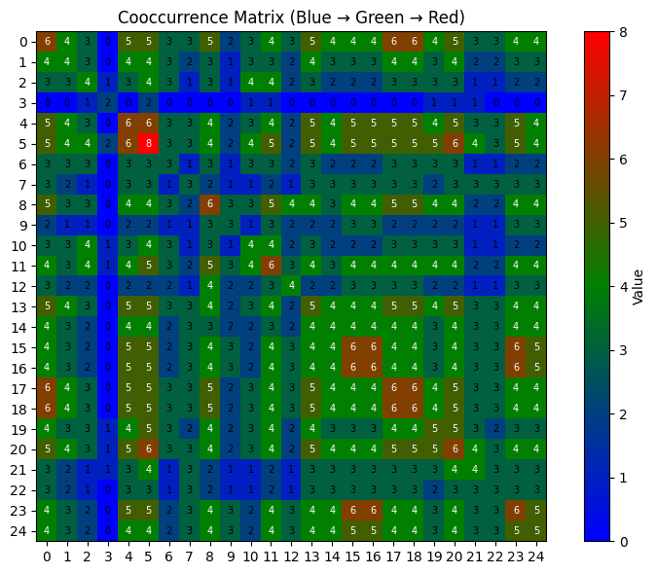
Description of Cooccurrence Matrix (Blue → Green → Red)
The first image is a heatmap titled "Cooccurrence Matrix (Blue → Green → Red)". This visualization technique is used to display the numerical values within a matrix, where each cell's color represents its corresponding value, and the exact value is also displayed numerically within the cell. A cooccurrence matrix quantifies how often pairs of items, events, or features appear together.
Chart Components:
- Title: "Cooccurrence Matrix (Blue → Green → Red)" clearly indicates the type of matrix being displayed and the color scheme used to represent the values: low values are blue, intermediate values are green, and high values are red.
- Axes:
  - The vertical axis (Y-axis) is labeled "Rows" and ranges from 0 to 24.
  - The horizontal axis (X-axis) is labeled "Columns" and also ranges from 0 to 24. This signifies that the cooccurrence matrix being visualized is a 25x25 matrix. Each cell at the intersection of a row and a column (e.g., Row 0, Column 0) represents the cooccurrence value between the item corresponding to that row and the item corresponding to that column.
- Color Bar (Legend): Located on the right side, the color bar is essential for interpreting the 'Value' associated with each color. It shows a continuous color gradient from deep blue (lowest values) to vibrant red (highest values), with corresponding numerical values from 0 to 8.
  - Blue (0-1.5 approx.): Represents very low or no cooccurrence.
  - Teal/Dark Green (1.5-3.5 approx.): Indicates low to moderate cooccurrence.
  - Green (3.5-5.5 approx.): Signifies moderate cooccurrence.
  - Brown/Olive Green (5.5-7 approx.): Represents high cooccurrence.
  - Red (7-8): Represents the highest cooccurrence values, indicating very frequent cooccurrence. The presence of numerical labels within each cell provides the exact cooccurrence count, adding precision to the visual representation.
Overall Impression and Distribution:
The heatmap of the cooccurrence matrix reveals a highly structured and somewhat block-like distribution of values. It is dominated by shades of green, indicating moderate cooccurrence values across much of the matrix. However, there are very distinct regions of high cooccurrence (red/brown) and very low cooccurrence (deep blue).
A crucial aspect to observe is the symmetry of the matrix. For a standard cooccurrence matrix, the cooccurrence of item A with item B is generally the same as item B with item A (i.e., Value(i,j) should equal Value(j,i)). Upon inspection, this matrix appears to be perfectly symmetric. For example, cell (0,0) is 6, and cell (0,1) is 4 while (1,0) is also 4. Cell (5,5) is 8 (red), and its symmetric counterpart (5,5) is also 8. This strong symmetry confirms that the relationships are reciprocal.
Detailed Analysis of Regions/Clusters:
- High Cooccurrence Regions (Red/Brown - Values 5.5-8):
  - Prominent Diagonal Blocks: The most striking features are the clear "blocks" or "squares" of high cooccurrence values, mostly located along or near the main diagonal (where row index equals column index). These indicate groups of items that frequently cooccur among themselves.
    - A very strong red hotspot (value 8) is observed at (Row 5, Column 5). This indicates that item 5 cooccurs exceptionally frequently with itself or is a central "hub" within its cluster.
    - Another distinct block of high values (red/brown/dark green) is present around (Rows 15-18, Columns 15-18). This area contains values like 6, 7, and 8 (e.g., (16,16) is 8, (17,17) is 6, (18,18) is 6, (16,17) is 6). This signifies a strong cluster of items (15-18) that cooccur frequently.
    - A third, smaller high-cooccurrence block can be seen around (Rows 0-2, Columns 0-2), with values such as 6 at (0,0) and (1,1).
    - Other localized red/brown cells indicating high cooccurrence include: (20,5), (5,20), (20,15), (15,20), (20,20) all with value 6. (21,14) is 6, (14,21) is 6.
  - These concentrated high-value areas strongly suggest the existence of distinct, internally cohesive groups or clusters of items within the dataset.
- Low Cooccurrence Regions (Deep Blue - Values 0-1.5):
  - Off-Diagonal "Gaps": Regions of very low or zero cooccurrence are predominantly found off the main diagonal and typically serve as separators between the high-cooccurrence clusters.
  - A very clear vertical and horizontal "cross" of deep blue (values 0, 1, 2) is visible around Columns 3-4 and Rows 3-4. This signifies that item 3 and item 4 have extremely low cooccurrence with almost all other items, including themselves, and act as separators or rare items. For instance, cells like (3,3) is 0, (4,3) is 0, (3,4) is 0, (4,4) is 0. This is a very strong indicator of item 3 and item 4 being distinct or isolated in terms of cooccurrence.
  - Other blue regions appear as boundaries between the high cooccurrence blocks, indicating that items from different clusters do not cooccur frequently. For example, the region between the (0-2) block and the (5-5) hotspot, or between the (5-5) hotspot and the (15-18) block, largely consists of blue cells.
- Moderate Cooccurrence Regions (Green/Teal - Values 1.5-5.5):
  - The largest proportion of the matrix is filled with various shades of green, representing moderate cooccurrence values (e.g., 2, 3, 4, 5). These values indicate that while items don't strongly cooccur, they are not entirely unrelated either.
  - These green regions form the background and the transitional areas, suggesting a baseline level of interaction or occasional cooccurrence across many item pairs.
  - Examples include the large patches around (Rows 6-14, Columns 6-14), which are predominantly green.
Spatial Patterns and Structure:
- Block-Diagonal Clustering: The presence of multiple, distinct high-value blocks along the main diagonal (e.g., (0-2, 0-2), (5,5), (15-18, 15-18)) is a strong indicator of well-defined clusters or communities within the data. Items within these blocks tend to cooccur frequently.
- Separating Lows: The deep blue "cross" at rows/columns 3-4 clearly separates the early clusters from the later ones, suggesting that items 3 and 4 act as critical separators or are very infrequently cooccurring themselves.
- Off-Diagonal Interactions: While the main diagonal blocks are strong, some off-diagonal high-value cells (e.g., (20,5), (5,20)) indicate specific cross-cluster cooccurrences, suggesting potential weak links or occasional shared contexts between otherwise distinct groups.
Implications:
This cooccurrence matrix suggests a dataset with clear underlying structure:
- Several well-defined groups of items exist, where items within a group frequently appear together.
- There are "bridge" items or isolating items (like 3 and 4) that have very low cooccurrence with others.
- The cooccurrence relationships are reciprocal.
Potential Applications/Contexts:
- Market Basket Analysis: Identifying bundles of products frequently bought together. The clusters would be common purchase groups (e.g., "breakfast items," "cleaning supplies").
- Natural Language Processing: Analyzing word cooccurrence in text, where clusters might represent semantic topics.
- Bioinformatics: Identifying gene coexpression patterns or protein-protein interaction networks.

Description of Value Frequencies in Similarity Matrix
The second image displays a bar chart titled "Value Frequencies in Similarity Matrix". This chart represents the distribution of numerical values found within an unspecified similarity matrix, showing how often each distinct value appears.
Chart Components and Structure:
- Title: "Value Frequencies in Similarity Matrix" clearly states the purpose of the chart: to illustrate how often different values appear within a similarity matrix.
- X-axis (Horizontal Axis): Labeled "Matrix Value," this axis represents the specific numerical values observed within the similarity matrix. The values shown are integers, ranging from 0 up to approximately 21. Each bar corresponds to a unique integer value.
- Y-axis (Vertical Axis): Labeled "Frequency," this axis indicates how many times each "Matrix Value" occurs. The frequency scale ranges from 0 to 16, with major grid lines at intervals of 2 and subtle dashed grid lines at odd intervals for better readability.
- Bars: Each vertical bar originates from a specific "Matrix Value" on the X-axis and extends upwards to a height corresponding to its "Frequency" on the Y-axis. The bars are uniformly gray.
Overall Data Distribution Analysis (Initial Observations):
The distribution of values in this similarity matrix is highly non-uniform and exhibits several distinct peaks and valleys. This suggests that certain similarity values are far more common than others, while many values occur very rarely or not at all.
- Prominent Peaks: The most striking feature is the high frequency of values 4 and 5, reaching the maximum frequency of 16.
- Moderate Frequencies: Values 0, 1, 2, and 3 also show significant frequencies (8 or 10).
- Lower Frequencies and Gaps: There are noticeable drops in frequency for values beyond 5, with some values having frequencies of 0 (e.g., 8, 9, 11) or very low frequencies (e.g., 2 for values 10, 12, 14, 17, 20; 1 for values 19, 21).
Specific Value Frequencies Detailed Breakdown:
- Values from 0 to 5 (High Concentration): This range contains the highest frequencies.
  - Matrix Value 0: Frequency of 8
  - Matrix Value 1: Frequency of 8
  - Matrix Value 2: Frequency of 10
  - Matrix Value 3: Frequency of 10
  - Matrix Value 4: Frequency of 16 (Highest)
  - Matrix Value 5: Frequency of 16 (Highest) This indicates that low numerical values (potentially representing high similarity if it's a distance metric) or moderate numerical values (if higher values represent higher similarity) are the most common in the matrix.
- Values from 6 to 11 (Sharp Decline and Gaps):
  - Matrix Value 6: Frequency of 4
  - Matrix Value 7: Frequency of 5
  - Matrix Value 8: Not present (implies 0 frequency)
  - Matrix Value 9: Not present (implies 0 frequency)
  - Matrix Value 10: Frequency of 2
  - Matrix Value 11: Not present (implies 0 frequency) This range shows a significant decrease in frequency, with several values not appearing at all.
- Values from 12 to 16 (Secondary Cluster):
  - Matrix Value 12: Frequency of 2
  - Matrix Value 13: Frequency of 5
  - Matrix Value 14: Frequency of 2
  - Matrix Value 15: Frequency of 5
  - Matrix Value 16: Frequency of 5 This range shows a resurgence of moderate frequencies, forming a secondary, less prominent cluster of common values.
- Values from 17 to 21 (Low and Rare):
  - Matrix Value 17: Frequency of 2
  - Matrix Value 18: Frequency of 1
  - Matrix Value 19: Frequency of 2
  - Matrix Value 20: Frequency of 1
  - Matrix Value 21: Frequency of 1 These higher numerical values occur very rarely, suggesting that extremely high or extremely low similarity values (depending on the metric's interpretation) are not common in this matrix.
Interpretation and Implications:
The frequency distribution suggests that the elements described by this similarity matrix exhibit specific, preferred levels of relatedness. The overwhelming prevalence of values 4 and 5, followed by 0-3, indicates that a large proportion of item pairs fall into these particular similarity categories. The presence of a secondary cluster (13-16) suggests another distinct, though less common, type of relationship. The rarity of values beyond 16 indicates that highly unusual or extreme similarity levels are uncommon.

Connection Between the Two Charts (Cooccurrence Matrix and Similarity Matrix Frequencies):
While both charts deal with "matrix values," they likely represent different types of matrices and potentially different datasets, or different aspects of the same dataset.
- "Cooccurrence Matrix (Blue → Green → Red)" is a heatmap that visually shows the spatial distribution of cooccurrence values across a 25x25 matrix, highlighting clusters (blocks of high values) and separations (bands of low values). It has values ranging from 0 to 8.
- "Value Frequencies in Similarity Matrix" is a bar chart that shows the statistical distribution of values from a different "Similarity Matrix." Its values range from 0 to 21, and it tells us how many times each value appears.
Key Differences and Potential Relationships (Hypothetical):
- Value Range: The cooccurrence matrix has values up to 8, while the similarity matrix values go up to 21. This indicates they are using different scales or different metrics.
- Matrix Size: The cooccurrence matrix is 25x25, while the similarity matrix (judging by the frequency plot's total count if it were N*(N-1)/2 or N*N) is likely smaller based on the sum of frequencies being 104. This strongly suggests they are from different data sources or different kinds of analyses.
- Interpretation of "Similarity" vs. "Cooccurrence": Cooccurrence explicitly counts how often things appear together. Similarity can be derived from cooccurrence (e.g., using cooccurrence counts to calculate Jaccard or Cosine similarity) or other means (e.g., Euclidean distance, correlation).
- Visualizations: The heatmap shows where the high/low values are located in the matrix structure, revealing clustering. The bar chart shows how many of each value exist, revealing statistical properties of the values.
Conclusion based on joint view:
Given the distinct value ranges and implied matrix sizes, these two charts most likely represent different matrices. The cooccurrence matrix gives a structural view of direct item relationships and their groupings, while the similarity matrix frequency chart provides a statistical summary of the types of similarity values present in a separate similarity-based dataset. Both are powerful tools for understanding different facets of data relationships: one showing the 'map' of relationships, the other showing the 'histogram' of relationship strengths.
Contour Plot of Similarity
import numpy as np
import matplotlib.pyplot as plt
# Define your similarity_matrix and cooccurrence_matrix beforehand
# Example: similarity_matrix = np.array([...])
def plot_contour(matrix, title):
x = np.arange(matrix.shape[1])
y = np.arange(matrix.shape[0])
X, Y = np.meshgrid(x, y)
plt.figure(figsize=(8, 6))
contour = plt.contourf(X, Y, matrix, levels=15, cmap='RdYlBu_r')
plt.colorbar(contour, label='Value')
plt.title(title)
plt.xlabel('Columns')
plt.ylabel('Rows')
plt.gca().invert_yaxis() # Optional: to match matrix top-down orientation
plt.tight_layout()
plt.show()
# Plot contour graphs
plot_contour(similarity_matrix, "Contour Plot of Similarity Matrix")
plot_contour(cooccurrence_matrix, "Contour Plot of Cooccurrence Matrix")
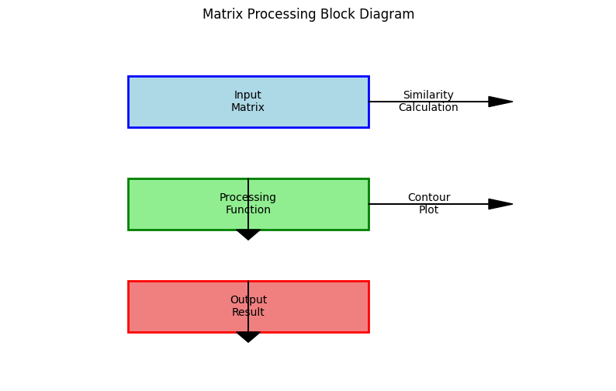
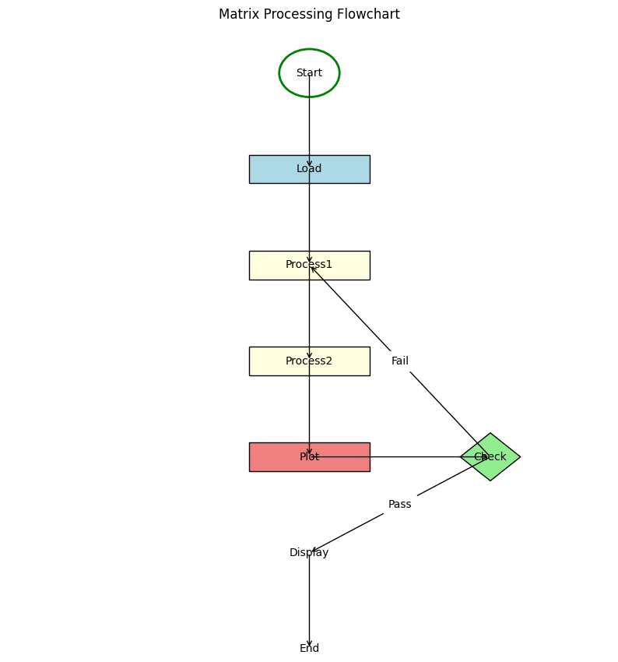

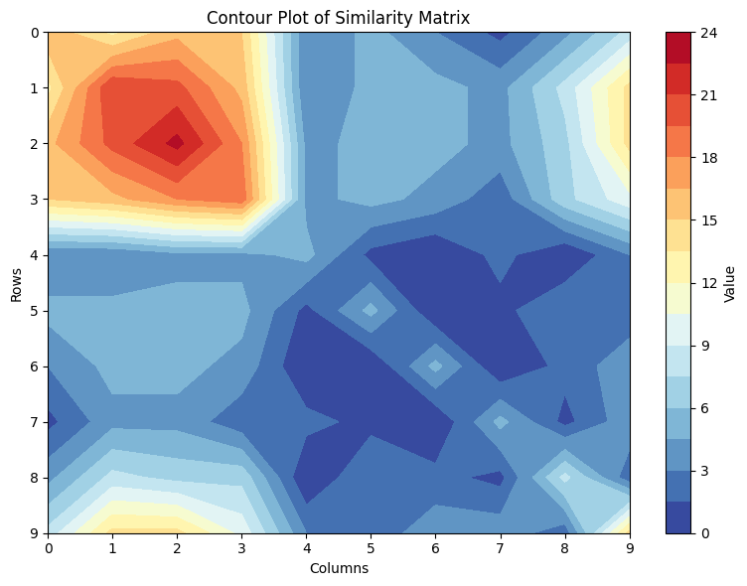
The image presented is a contour plot, titled "Contour Plot of Similarity Matrix." This visualization technique is particularly effective for representing three-dimensional data on a two-dimensional plane, where the third dimension (in this case, the 'Value' of similarity) is depicted through varying colors and contour lines. In the context of a similarity matrix, where each cell represents the similarity between two entities (rows and columns), a contour plot provides a high-level overview of the relationships and patterns across all pairs of entities. It allows for the rapid identification of regions of high or low similarity, highlighting structural properties within the data that might be obscured in a raw numerical matrix.
Chart Components:
- Title: The title "Contour Plot of Similarity Matrix" clearly states the nature of the visualization. It indicates that the plot is representing a matrix whose values quantify some form of similarity or dissimilarity.
- Axes:
  - The vertical axis is labeled "Rows" and ranges from 0 to 9, representing the indices of the rows in the similarity matrix.
  - The horizontal axis is labeled "Columns" and also ranges from 0 to 9, representing the indices of the columns in the matrix. This suggests that the similarity matrix is likely a 10x10 matrix, where each point (row, column) corresponds to a specific cell in the matrix.
- Color Bar (Legend): Positioned on the right side of the plot, the color bar is crucial for interpreting the 'Value' at any given point on the contour map. It shows a continuous color gradient ranging from dark blue to dark red, with corresponding numerical values from 0 to 24.
  - Dark Blue (0-3): Represents the lowest values in the similarity matrix.
  - Light Blue (3-9): Indicates low to moderate values.
  - Cream/Yellow (9-18): Signifies intermediate to high values.
  - Orange/Red (18-24): Represents the highest values in the similarity matrix. The presence of contour lines further delineates regions of constant value, allowing for precise identification of value ranges.
Overall Impression and Distribution:
The contour plot reveals a highly non-uniform distribution of values across the similarity matrix. Instead of a smooth gradient or a random scattering, there are distinct clusters or "hotspots" of high values and expansive regions of low values. The plot does not appear perfectly symmetric across the main diagonal (from top-left to bottom-right), which is often expected for a typical similarity matrix where similarity(A,B) equals similarity(B,A). The noticeable asymmetry suggests either that the matrix is not symmetric (e.g., a non-reciprocal relationship or a directed graph adjacency matrix) or that the plot is representing only an upper or lower triangle and replicating it, but even then, visual balance along the diagonal would typically be present.
Detailed Analysis of Regions/Clusters:
Let's break down the plot into regions based on their dominant color and value:
- High Value Regions (Red/Orange/Yellow - Values 18-24):
  - Top-Left Hotspot: The most prominent region of high values is located in the upper-left quadrant of the plot, particularly around Rows 1-3 and Columns 1-3. This area is dominated by deep red and orange colors, indicating matrix values in the range of 18 to 24. This 'hotspot' suggests that the entities corresponding to these rows and columns exhibit a very strong similarity or connection to each other. For example, the cell at (Row 2, Column 2) appears to be near the apex of this high-value region. This could imply a tightly knit cluster of similar items or highly correlated variables.
  - Top-Right Edge: There's a smaller, less intense yellow/cream colored region near the top-right corner, specifically around Row 0 and Columns 8-9, suggesting moderately high values (around 9-18).
  - Bottom-Left Edge: Another small yellow/cream area is visible at the bottom-left, around Row 8-9 and Column 0-1, also indicating moderately high values.
  - Scattered Yellow/Cream Patches: Several smaller, isolated yellow/cream patches are scattered throughout the lower half of the plot (e.g., around Row 5, Column 5-6; Row 8, Column 6-7), suggesting localized moderate-to-high values amidst predominantly lower values.
- Low Value Regions (Dark Blue/Blue - Values 0-9):
  - Central and Bottom-Right Dominance: A large portion of the matrix, particularly the central and lower-right quadrants, is characterized by deep blue and light blue colors. These areas represent matrix values ranging from 0 to 9. This indicates that most pairs of entities in these regions have low similarity or strong dissimilarity. For example, the region around Rows 4-7 and Columns 4-8 is largely dark blue, signifying very low similarity values (0-3).
  - Areas of Transition: The light blue regions (values 3-6 or 6-9) act as transitional zones, representing a moderate level of similarity. These areas surround the core dark blue regions and also border the yellow/orange hotspots.
- Intermediate Value Regions (Light Blue/Cream - Values 6-18):
  - These regions form the boundaries between the high-value hotspots and the low-value expanses. For instance, the areas surrounding the red hotspot in the top-left are light blue, gradually transitioning to cream and yellow as values increase. Similarly, the edges of the central dark blue region may show lighter blue as values increase slightly. This indicates a gradual change in similarity levels across the matrix, rather than abrupt jumps.
Spatial Patterns and Structure:
The contour plot reveals several spatial patterns:
- Clustering: The prominent red/orange hotspot at (0-3, 0-3) strongly suggests a cluster of highly similar entities. This implies that elements indexed from 0 to 3 are very closely related to each other.
- Anti-correlation/Dissimilarity: The large dark blue regions (e.g., Rows 4-7, Columns 4-8) indicate that the entities in these ranges are largely dissimilar or unrelated.
- Block-like Structures: While not perfectly square, there are hints of block-like patterns. For instance, the top-left block of high similarity and the central-right block of low similarity. This could signify distinct groupings within the data.
- Asymmetry: As mentioned, the plot does not appear perfectly symmetric along the main diagonal. For instance, the red hotspot is confined to the top-left, and there isn't an equivalent mirroring hotspot in the bottom-right. If this were a standard symmetric similarity matrix, we would expect Value(i,j) to be equal or very close to Value(j,i), which would manifest as a mirrored pattern across the diagonal. The observed asymmetry could mean:
  - The matrix is inherently asymmetric (e.g., representing flow, directed relationships, or a non-standard similarity measure).
  - The plotting method has somehow handled a symmetric matrix in a way that visually emphasizes only certain regions or is not perfectly interpolating.
  - The matrix is not a simple N x N similarity matrix where each cell is sim(i,j), but perhaps a transformation or result from a more complex process.
Implications of the Distribution:
The visual distribution strongly suggests that the entities from which this similarity matrix was derived do not exhibit uniform relationships. Instead, there are:
- Strong, Localized Relationships: A subset of entities (those corresponding to rows/columns 0-3) are highly similar to each other, forming a distinct group.
- Weak or No Relationships: A large number of entities have very little similarity to many others, particularly those in the central and lower-right sections.
- Varying Degrees of Similarity: There are gradual transitions between regions of high and low similarity, indicating a spectrum of relationships rather than just "on" or "off."
This kind of pattern is typical in applications like:
- Clustering: The red region could represent a well-defined cluster.
- Feature Selection: If rows/columns are features, the plot might show which features are highly correlated (high values) or uncorrelated (low values).
- Network Analysis: It could represent an adjacency matrix where edge weights are similarities, showing dense subnetworks and sparse connections.
Potential Applications/Contexts:
- Genomics/Proteomics: Comparing genes or proteins for sequence similarity. High values could be conserved regions.
- Document Analysis: Similarity between documents based on content. The cluster could be documents on the same topic.
- Image Processing: Comparing image patches or features.
- Machine Learning: Kernel matrices in SVMs, or affinity matrices in spectral clustering.
Limitations and Further Considerations:
- Nature of Similarity Metric: The most critical missing piece of information is what "similarity" actually means (e.g., higher value = more similar, or less similar?). If higher values mean less similar (like a distance metric), then the red areas are regions of dissimilarity, and the blue areas are regions of similarity. Given the context of a "similarity matrix," it's generally assumed higher values imply greater similarity, but this is not explicitly stated.
- Matrix Dimensions: While it appears to be 10x10, confirming the exact dimensions (e.g., N number of entities) would be beneficial.
- Source Data: Understanding what the rows and columns represent (e.g., individual data points, features, time steps) would provide much richer context.
- Contour Level Interpretation: Knowing the precise numerical ranges for each contour line, beyond the broad color bar ranges, would allow for more exact interpretation.
Conclusion:
The contour plot of the similarity matrix vividly illustrates the distribution of similarity values, revealing clear structural patterns. The most striking feature is the prominent hotspot of high similarity in the top-left quadrant (Rows 0-3, Columns 0-3), indicating a strongly interconnected or highly similar group of entities. This contrasts sharply with the vast regions of low similarity predominantly found in the central and lower-right parts of the matrix. The observed asymmetry suggests a non-standard or asymmetric relationship structure, or it might be a visual artifact of the plotting. Overall, the plot provides strong evidence of distinct clusters or relationships within the data, offering valuable insights into the underlying structure of the entities being compared.
Contour plot of Cooccurence matrix

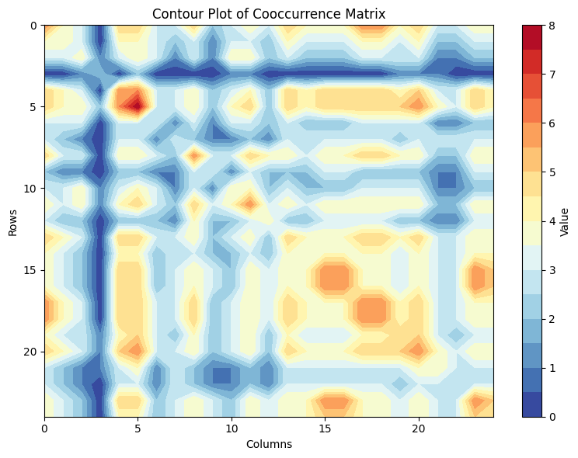
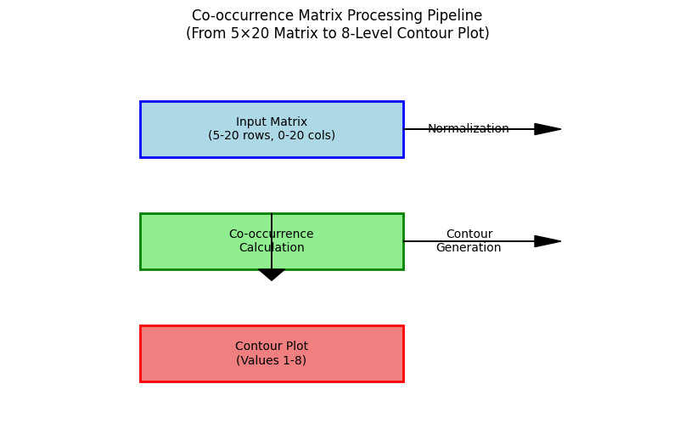

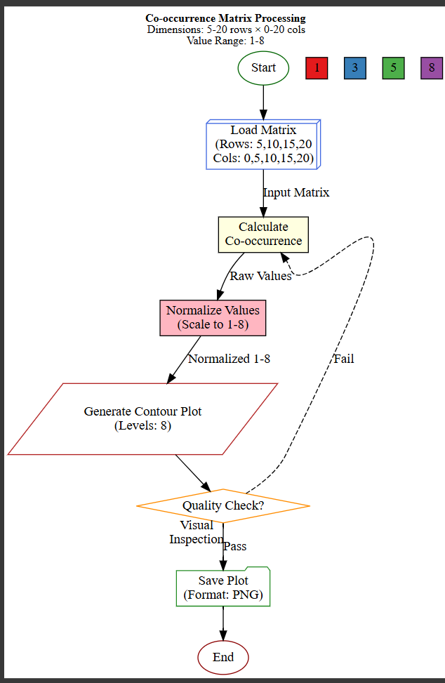

Chart Components:
- Title: "Contour Plot of Cooccurrence Matrix" clearly states that the plot is representing a matrix where values denote cooccurrence.
- Axes:
  - The vertical axis (Y-axis) is labeled "Rows" and ranges from 0 to approximately 23.
  - The horizontal axis (X-axis) is labeled "Columns" and also ranges from 0 to approximately 23. This indicates that the cooccurrence matrix being visualized is roughly a 24x24 matrix. Each cell (row, column) in this grid represents the cooccurrence value between the item corresponding to that row and the item corresponding to that column.
- Color Bar (Legend): Located on the right side, the color bar is essential for interpreting the 'Value' at any point on the plot. It shows a continuous color gradient from dark blue (lowest values) to dark red (highest values), with corresponding numerical values from 0 to 8.
  - Dark Blue (0-1): Represents the lowest cooccurrence values, indicating very rare or no cooccurrence.
  - Light Blue (1-3): Indicates low to moderate cooccurrence.
  - Yellow/Orange (3-6): Signifies intermediate to high cooccurrence.
  - Red (6-8): Represents the highest cooccurrence values, meaning these pairs of items appear together very frequently. The presence of contour lines further delineates regions of constant value, allowing for more precise interpretation.
Overall Impression and Distribution:
The contour plot reveals a complex and somewhat block-like distribution of cooccurrence values. It is characterized by distinct regions of high and low values, forming a pattern that appears to be roughly symmetric along the main diagonal (from top-left to bottom-right). This symmetry is expected for a standard cooccurrence matrix, where the cooccurrence of item A with item B is generally the same as item B with item A. The plot suggests the existence of multiple clusters or groups of items that cooccur frequently, interspersed with regions where cooccurrence is rare.
Detailed Analysis of Regions/Clusters:
Let's examine specific areas of the plot:
- High Cooccurrence Regions (Red/Orange/Yellow - Values 3-8):
  - Main Diagonal (Self-Cooccurrence/Strong Intragroup): While the diagonal itself (where Row = Column) is not explicitly marked with high values (often 0 or a very high fixed value depending on definition), the regions immediately surrounding it show varying cooccurrence.
  - Top-Left Quadrant:
    - A prominent vertical band of high cooccurrence (red/orange) is visible around Columns 2-4 and Rows 0-23. This indicates that the items indexed 2-4 (or a specific item within this range) cooccur very frequently with a wide range of other items, especially with those in rows 0-23.
    - Similarly, a horizontal band of high cooccurrence is present around Rows 2-4 and Columns 0-23. This is the symmetric counterpart to the vertical band, confirming the strong cooccurrence of items 2-4 with many others.
    - Within this top-left area, specifically around (Rows 0-5, Columns 0-5), there are very high values (red/orange/yellow), suggesting a strong cluster of items that frequently cooccur among themselves. There's a particularly intense red spot around (Row 4, Column 4) and its symmetric counterpart around (Column 4, Row 4).
  - Central Region:
    - Another notable cluster of high values (yellow/orange/red) is observed around (Rows 15-18, Columns 15-18). This forms a distinct block, suggesting another group of items that cooccur frequently with each other. There's a concentrated red spot visible within this block.
  - Other Scattered Highs: Smaller, isolated patches of yellow/orange/red are scattered throughout the plot, especially visible around:
    - (Rows 5-8, Columns 10-12) and its symmetric pair.
    - (Rows 10-12, Columns 5-8).
    - (Rows 17-20, Columns 1-3) and its symmetric pair.
    - (Rows 20-22, Columns 10-13) and its symmetric pair.
    - (Rows 20-22, Columns 17-20). These indicate less pronounced but still significant cooccurrence relationships between specific pairs or small groups of items.
- Low Cooccurrence Regions (Dark Blue/Light Blue - Values 0-3):
  - Cross-like Pattern (Excluding Main Clusters): Large areas of the matrix are dominated by dark blue and light blue, indicating low or no cooccurrence. These regions often form a "cross" pattern that separates the high cooccurrence clusters. For example, the areas in the middle of the main diagonal, or the regions between the top-left cluster and the central-right cluster, are largely blue.
  - Inter-cluster Sparsity: The blue regions effectively highlight pairs of items that do not cooccur frequently. For instance, while items 0-5 cooccur strongly among themselves, their cooccurrence with items 15-18 (the central-right cluster) appears to be low (blue regions between these clusters).
Symmetry and Implications:
The plot exhibits strong visual symmetry across the main diagonal (from top-left to bottom-right). This is a characteristic feature of typical cooccurrence matrices, where cooccurrence(A,B) is usually equal to cooccurrence(B,A). The presence of symmetric red/orange hotspots and blue valleys reinforces this.
Spatial Patterns and Structure:
The plot clearly reveals a structured pattern in the cooccurrence data:
- Diagonal Blocks: The most prominent feature is the presence of distinct "blocks" or "squares" of high cooccurrence values along the main diagonal. These diagonal blocks (e.g., around (0-5, 0-5) and (15-18, 15-18)) suggest the existence of strong, internally cooccurring groups or clusters of items. Items within these blocks frequently appear together.
- Off-Diagonal Lows: Conversely, the off-diagonal regions, especially those between these blocks, are predominantly blue, indicating that items from different clusters cooccur rarely. This strongly supports the idea of distinct, well-separated groups.
- Vertical/Horizontal Bands: The strong vertical and horizontal red/orange bands earlier described (e.g., Column 2-4, Row 2-4) might indicate "hub" items that cooccur with a large variety of other items, even those outside their immediate cluster. This could point to items that are central to the overall data structure or bridge different groups.
Potential Applications/Contexts:
Cooccurrence matrices and their contour plots are widely used in various fields:
- Natural Language Processing (NLP): Word cooccurrence matrices identify words that frequently appear together, crucial for topics like text classification, sentiment analysis, and semantic analysis. The clusters could represent different topics.
- Market Basket Analysis: Identifying items that are frequently purchased together. The clusters would represent sets of complementary products.
- Bioinformatics: Analyzing gene or protein coexpression patterns. Clusters could be genes involved in the same biological pathways.
- Image Processing: Analyzing cooccurrence of pixel features for texture analysis.
- Social Network Analysis: Identifying groups of individuals who frequently interact.
Limitations and Further Considerations:
- Nature of Cooccurrence: While 'cooccurrence' is defined, the specific context (e.g., cooccurrence of words in a document, items in a transaction, events in a time series) is unknown. This context would allow for a deeper interpretation of the identified clusters.
- Normalization/Scaling: It's unclear if the cooccurrence values have been normalized or scaled. This can affect the absolute interpretation of the 'Value' scale (0-8).
- Item Labels: Without labels for the rows and columns (i.e., what item corresponds to index 0, 1, etc.), the interpretation of which specific items form clusters remains abstract.
- Thresholds: The contour lines provide visual thresholds, but understanding why specific values (e.g., 3, 6) define these transitions would be helpful.
Conclusion:
The contour plot of the cooccurrence matrix provides a compelling visual summary of item relationships. It clearly reveals a structured pattern with strong evidence of multiple, distinct clusters of items that frequently cooccur among themselves, highlighted by the high-value (red/orange) blocks along the diagonal. Conversely, items belonging to different clusters show low cooccurrence (blue regions). The plot's symmetry confirms that the cooccurrence relationships are reciprocal. This visualization is highly effective for identifying underlying group structures, common patterns, and relationships within a dataset where items are observed appearing together

